A Project Report on
AN AI-DRIVEN MULTI LINGUAL GOVERNMENT DOCUMENT TRANSLATING SYSTEM USING OCR & RAG
A Project Report Submitted in partial fulfillment of the Requirement for the Award of the degree of

BACHELOR OF TECHNOLOGY
IN
C OMPUTER SCIENCE AND ENGINEERING
(DATA SCIENCE)

Submitted by

C. Sailaja 22091A32C3
M. Kaveri 22091A3255
K. Venkata Subramanyam 22091A32G5

Under the Supervision of
Mr. G. Vikram Chandra, M. Tech., (Ph. D)


Assistant Professor, Dept. of CSE(DS)

DEPARTMENT OF COMPUTER SCIENCE AND ENGINEERING
(DATA SCIENCE)

RAJEEV GANDHI MEMORIAL COLLEGE OF ENGINEERING & TECHNOLOGY (AUTONOMOUS)
Approved by AICTE, New Delhi; Affiliated to JNTUA-Ananthapuramu,
Accredited by NBA (6-Times); Accredited by NAAC with ‘A+’ Grade (Cycle-3), New Delhi; World Bank Funded Institution; Nandyal (Dist)-518501, A.P.

YEAR: 2025-2026





A Project Report on
CARDIOVASCULAR DISEASE (CVD) PREDICTION AND CLASSIFICATION FRAMEWORK USING MACHINE LEARNING TECHNIQUES
A Project Report Submitted in partial fulfillment of the Requirement for the Award of the degree of
BACHELOR OF TECHNOLOGY
IN
COMPUTER SCIENCE AND ENGINEERING (DATA SCIENCE)

Submitted by

P. Satish Kumar | 21091A3243
K. Meghana  S. Harshitha | 21091A3223  21091A3214
C. Dharani | 21091A3211

Under the Supervision of

Supervisor Co-Supervisor
Mr. B. Bhaskara Rao M. Tech, (Ph.D.) Mr. G. Vikram Chandra M. Tech

Associate Professor & HOD, Dept. of CSE (DS) Assistant Professor, Dept. of CSE(DS)

DEPARTMENT OF COMPUTER SCIENCE AND ENGINEERING (DATA SCIENCE) RAJEE V GANDHI MEMORIAL COLLEGE OF ENGINEERING & TECHNOLOGY
(AUTONOMOUS)

Approved by AICTE, New Delhi; Affiliated to JNTUA-Ananthapuramu,
Accredited by NBA (6-Times); Accredited by NAAC with “A+‟ Grade (Cycle-3), New Delhi; World Bank Funded Institution; Nandyal (Dist)-518501, A.P.

YEAR: 2025-2026

RAJEEV GANDHI MEMORIAL COLLEGE OF ENGINEERING & TECHNOLOGY
(AUTONOMOUS)
Approved by AICTE, New Delhi; Affiliated to JNTUA-Ananthapuramu, Accredited by NBA (6-Times); Accredited by NAAC with “A+‟ Grade (Cycle-3), New Delhi;


World Bank Funded Institution; Nandyal (Dist)-518501, A.P

(ESTD – 1995)
DEPARTMENT OF COMPUTER SCIENCE AND ENGINEERING (DATA SCIENCE)
CERTIFICATE
This is to certify that P. Satish Kumar (21091A3243), K. Meghana (21091A3223),
S. Harshitha (21091A3214), and C. Dharani (21091A3211) of IV- B. Tech II- Semester, have carried out the major project work entitled “CARDIOVASCULAR DISEASE (CVD) PREDICTION AND CLASSIFICATION FRAMEWORK USING MACHINE
LEARNING TECHNIQUES” under the supervision and guidance of Mr. B. Bhaskara Rao, Associate Professor & HOD, CSE(DS) Department, and Mr. G. Vikram Chandra, Assistant Professor, CSE(DS) Department, in partial fulfillment of the requirements for the award of Degree of Bachelor of Technology in Computer Science and Engineering (Data Science) from Rajeev Gandhi Memorial College of Engineering & Technology (Autonomous), Nandyal is a bonafied record of the work done by them during 2025-2026.

Project Supervisor Head of the Department
Mr.B. Bhaskara Rao, M.Tech, (Ph.D.) Mr. B. Bhaskara Rao M.Tech, (Ph.D.)
Associate Professor& HOD, Dept. of CSE(DS) Associate Professor, Dept. of CSE(DS)

Co-Supervisor
Mr. G. Vikram Chandra M. Tech
Assistant Professor, Dept. of CSE(DS) External Examiner

Place: Nandyal
Date:

Candidate’s Declaration

We hereby declare that the work done in this project entitled “CARDIOVASCULAR DISEASE PREDICTION AND CLASSIFICATION FRAMEWORK UISNG MACHINE
LEARNING TECHNIQUES” submitted towards completion of the major project in IV- Year II- Semester of B. Tech CSE (Data Science) at the Rajeev Gandhi Memorial College of Engineering & Technology (Autonomous), Nandyal. It is an authentic record of our original work done under the esteemed guidance of Dr. B Bhaskara Rao, Associate Professor, Department of Computer Science and Engineering (Data Science), and Msr G Vikram Chnadra, Assistant Professor, Department of Computer Science and Engineering (Data Science), RGMCET(Autonomous), Nandyal.

We have not submitted the matter embodied in this report for the award of any other Degree in any other institutions for the academic year 2025-2026.

By
P. Satish Kumar 21091A3243
K. Meghana 21091A3223
S. Harshitha 21091A3214
C. Dharani 21091A3211

Dept. of CSE(DS), RGMCET(Autonomous).

Place: Nandyal
Date:

ACKNOWLEDGEMENT

We manifest our heartier thankfulness of your contentment over our project guide Mr. B. Bhaskara Rao, Associate Professor & HOD of Computer Science Engineering (Data Science) department, and Mr. G. Vikram Chandra, Assistant Professor of Computer Science Engineering (Data Science) department, with whose adroit concomitance the excellence has been exemplified in bringing out this project to work with artistry.
We express our gratitude to Mr. B. Bhaskara Rao, Head of the Department of Computer Science Engineering (Data Science) department, and all the Teaching Staff Members of the Computer Science Engineering (Data Science) of Rajeev Gandhi Memorial College of Engineering and Technology for providing continuous encouragement and cooperation at various steps of our project successful.
Involuntarily, we are perspicuous to divulge our sincere gratefulness to our Principal, Dr. T. Jayachandra Prasad who has been observed posing valiance in abundance towards our individuality to acknowledge our project work tangentially.
At the outset, we thank our honourable Chairman Dr. M. Santhiramudu garu, for providing us with exceptional faculty and moral support throughout the course.
Finally, we extend our sincere thanks to all the non-teaching Staff Members of the CSE(DS) Department who have co-operated and encouraged us in making our project successful.
Whatever one does, whatever one achieves, the first credit goes to the Parents be it not for their love and affection, nothing would have been responsible. We see in every good that happens to us their love and blessings.

BY

P. Satish Kumar 21091A3243
K. Meghana 21091A3223
S. Harshitha 21091A3214
C. Dharani 21091A3211

ABSTRACT

Heart disease contributes to the highest death rates globally. Therefore, early diagnosis is crucial to improve mortality and overall health. This research introduces a hybrid method for predicting heart disease, utilizing machine learning alongside both private and public datasets. It incorporates advanced techniques like feature selection and the Synthetic Minority Oversampling Technique (SMOTE). Among the ten classifier models that were compared, XGBoost with the feature subset SF-2 stood out as the top performer, achieving an impressive accuracy rate of 97.57%.This study was deemed as an excellent and dependable predictive model. The research highlights the use of Explainable Artificial Intelligence incorporating SHAP to improve accuracy and trust. Users as well as healthcare professionals can make sense of the predictions easily. This way, regions with insufficient healthcare services can be provided with precise diagnostic aid from afar. In the next steps, a wider diversity of data sources will be included to enhance the prediction model‟s accuracy and scope. Fulfilling these objectives is expected to advance the automatic detection of heart disease and provide innovation for this particular healthcare field.

TABLE OF CONTENTS
CHAPTER NO CHAPTER NAME PAGE NO

1 INTRODUCTION
1.1 Background | 2
1.2 Problem Statement | 2
1.3 Objectives | 3

- LITERATURE SURVEY 5
- SYSTEM OVERVIEW
  - Introduction to System Overview 10
  - Existing System 10
  - Disadvantages of Existing System 11
  - Proposed System 11
  - Advantages of Proposed System 12
- METHODOLOGY
  - Data Collection 14
  - Data Preprocessing 14
- SYSTEM DESIGN
5.1 | System Architecture | 22
5.2 | Dataflow Diagram | 23
5.3 | UML Diagrams | 24
5.3.1 | Class Diagrams | 24
5.3.2 | Use case Diagrams | 25
5.3.3 | Sequence Diagrams | 26
5.3.4 | Collaboration Diagrams | 27

- SYSTEM REQUIREMENT SPECIFICATIONS(SRS)
  - Requirement Analysis 30
  - Software Requirement Specification 30
  - Functional Requirements 31
  - Non-Functional Requirements 31
  - Software Requirements 31
  - Hardware Requirements 31

- SYSTEM IMPLEMENTATION
7.1 | Modules | 33
7.2 | Development Environment | 36
7.2.1 | Python | 36
7.2.2 | History of Python | 37
7.2.3 | Features of Python | 38
7.2.4 | Advantages of Python | 39
7.2.5 | AWS account creation | 40
7.2.6 | Exploring the AWS Management console | 42
7.2.7 | AWS S3 for Data Storage | 43
7.2.8 | Amazon SageMaker for model deployement | 45
7.3 | Sample Code | 50

- RESULT AND ANALYSIS

8.1 Evaluation Metrics | 56
8.2 Screenshots | 59

- SYSTEM TESTING
  - Need for Testing 63
  - Types of Testing 64
- SYSTEM STUDY 69
- CONCLUSION AND FUTURE SCOPE
  - Summary of findings 71
  - Limitations 71
  - Conclusion & Future Scope 73
- REFERENCES 75
APPENDIX-A PLAGIARISM REPORT APPENDIX-B PATENT PUBLICATION

LIST OF FIGURES
FIGURES PAGE NO
Fig. 4.1.1 System Architecture 23
Fig 4.2.1 Data flow Diagram 24
Fig. 4.2.1.1 Class Diagram 25
Fig. 4.2.2.1 Use case Diagram 26
Fig. 4.2.3.1 Activity Diagram 27
Fig. 4.2.4.1 Sequence Diagram 28
Fig. 4.2.5.1 Collaboration Diagram 28
Fig. 7.2.5.1 AWS free tier web page 41

Fig. 7.2.5.2 AWS account sign in page 41
Fig. 7.2.5.3 AWS sign up: billing information page 42
Fig. 7.2.5.4 AWS identity verification page 42
Fig. 7.2.5.5 AWS account activtaion confirmation page 43
Fig. 7.3.6.1 AWS management console webpage 44
Fig. 7.3.7.1 AWS S3 console interface 46
Fig. 7.2.8.1 AWS SageMaker Notebook instance console 48
Fig. 7.4.1 Importing packages 51
Fig. 7.4.2 Loading the sample data 51
Fig. 7.4.3 Data Preprocessing 53
Fig. 7.4.4 Splitting the data set into training and testing 54
Fig. 7.4.5 Feature Selection 54
Fig. 7.4.6 Data Visualization 55

Fig. 8.1.1 Classification performance comparison of Accuracy Score 56
Fig. 8.1.2 Classification performance comparison of Precision Score 57
Fig. 8.1.3 Classification performance comparison of Recall Score 58
Fig. 8.1.4 Classification performance comparison of F1- Score 58
Fig. 8.2.1 Homepage 59
Fig. 8.2.2 Signup Page 60
Fig. 8.2.3 Login Page 60
Fig. 8.2.4 Heart Disease Prediction Input 61
Fig. 8.2.5 Heart Disease Prediction Output 61

LIST OF TABLES
Table 1 Features of the data set 16
Table 2 Performance Evaluation of different Classifiers 59

CHAPTER-1 INTRODUCTION

INTRODUCTION

Background:
Alarming rates of deaths caused by cardiovascular diseases signifies the need for a timely diagnosis as well as intervention. The oldest diagnostic tools for these diseases relied on visual interpretations and personal discretion, which often resulted in misdiagnoses and care delays.
Machine learning achievements provide meaningful prospects to healthcare professionals. Physicians who employ predictive models together with case classification spend enhanced capabilities to detect and handle heart diseases. The analysis of large amounts of data becomes possible through machine learning techniques which lead to effective filtering of unimportant information. The diagnosis turns more accurate by uncovering unknown patterns which leads to improved patient results along with superior threat control mechanisms.
The machine learning system will use real medical records to classify and predict heart diseases through this project. This research seeks to develop an extremely effective diagnostic tool that people can quickly understand. A diagnostic support system which clinicians can understand will be created through the integration of SHAP and SMOTE and feature selection techniques.

Problem Statement:
Worldwide heart diseases rank as the main cause of death because patients often receive late medical diagnosis and need better preventive healthcare. Manual screening methods are error-prone and risky in urgent cases. Traditional diagnostic methods like ECG, stress tests, and angiography require costly equipment and skilled professionals, making them inaccessible to poorer regions and prone to operator subjectivity. Modern medicine often overlooks asymptomatic patients and hidden risk factors. An automated system is needed to analyze large datasets, detect early warning signs, and diagnose heart disease in its earliest

stages. Medical datasets are complex and imbalanced, leading models to favor the majority class, resulting in overoptimistic predictions that neglect critical cases.

Objective:

This research establishes the design of an accurate and interpretable machine learning model which performs heart disease classification and prediction. State-of-the-art feature selection methods together with SHAP as an explainable Artificial Intelligence method and SMOTE as an oversampling technique will improve accuracy and explainability in the model. The study evaluates multiple machine learning approaches for determining the best methodology through which the system can be optimized for practical healthcare application.

CHAPTER-2 LITERATURE SURVEY

2 LITERATURE SURVEY

Overview of related work:
Heart disease has become a global issue thanks to its increasing prevalence. To address this, significant work within the realm of machine learning predictive models has been done. Continuous research demonstrates that supervised algorithms including XGBoost and Random Forest and Support Vector Machines (SVM) demonstrate effectiveness in heart disease stratification. Additionally, researchers have sought to improve model performance through so-called feature selection methods, which involve isolating the most informative variables. In addition, applying the Synthetic Minority Oversampling Technique (SMOTE) has proven beneficial when working with most healthcare datasets, as it allows predictive models to stop overfitting to the majority class. Explainable AI advances also support making AI-based predictive models more interpretable, which helps experts understand and trust artificial intelligence decisions.

Key concepts and technologies:
The arrival of machine learning in healthcare has opened up new avenues for predicting diseases through automated data analysis. Medical professionals can use machine learning models to detect heart disease patterns through the analysis of essential patient factors such as age as well as cholesterol levels and blood pressure measurements together with lifestyle behaviors. Unlike traditional diagnostic approaches that require manual assessment and professional judgment, machine learning models automate the information processing step, which makes the predictions more accurate and relies less on human input. Such models trained using historical patient information can learn to tell the difference between normal individuals and those who would be likely to develop heart ailments and facilitate early intervention and management. When it comes to classifying heart disease, supervised learning methods are crucial, no matter which approach is taken. The algorithms XGBoost, Random Forest and Support Vector Machines (SVM) prove effective for heart complications forecasting. XGBoost is particularly impressive due to its ability to manage missing values, prevent overfitting, and leverage gradient boosting for top-notch performance. On the other hand, Random Forest, which is part of ensemble learning techniques, Decision trees built in a

Sequence work to decrease model variability while increasing its trustworthiness.

Support Vector Machines (SVM) are helpful in classifying complicated datasets by projecting features into higher dimensions for enhanced separation of data points. These algorithms enable researchers and clinicians to evaluate heart disease risk factors more accurately, which results in better clinical decision-making.
Machine learning models rely heavily on feature selection, particularly when it comes to medical diagnosis. Essentially, it's all about figuring out which patient characteristics are most relevant for predicting heart disease while filtering out any unnecessary or less significant features. By choosing the most important variables, feature selection improves model interpretability, decreases computational complexity, and avoids overfitting. In medical data, typical predictive features are cholesterol level, resting blood pressure, maximum heart rate, and type of chest pain. The judicious choice of these attributes ensures that models concentrate on the most significant factors, leading to more accurate and consistent predictions.
Most medical datasets encounter a problem which results from their uneven class distribution since heart disease patients are significantly less prevalent than healthy people. The unequal representation affects model performance by causing the artificial intelligence system to favor the most common class while failing to detect genuine heart disease patients. A method called Synthetic Minority Oversampling Technique (SMOTE) creates synthetic data points for minority samples to address this problem. By resampling the dataset, SMOTE enhances the model's accuracy in detecting cases of heart disease so that the predictions are not biased toward the majority class. This method is especially crucial for healthcare application because failing to diagnose a positive condition can have detrimental effects.
Interpretability stands out as one of the major hurdles when it comes to applying machine learning in healthcare, primarily because understanding the model's predictions can be quite tricky. Doctors face difficulties understanding the reasons behind machine learning algorithm predictions since most algorithms function as opaque systems. SHAP, or Shapley Additive Explanations, is one example of an Explainable AI (XAI) method. They aim to tackle this issue by shedding light on how decisions are made within the

model, bringing much-needed transparency to the process. SHAP gives importance scored to every feature, illustrating how various patient characteristics contribute to the prediction. Understanding why a model predicts that a patient is high-risk is crucial in a clinical setting.
Criteria for selecting the best solution among machine learning models dominates the process of classifying heart disease. Different algorithms include specific strengths and weaknesses. XGBoost provides outstanding accuracy performance in addition to successful missing value management yet it demands substantial processing power from systems. Random Forest provides high stability and reduced variance in its predictions yet performs slowly for big data collections. The value of Support Vector Machines (SVM) lies in their excellence for high-dimensional spaces although users need to adapt parameters precisely for obtaining best results. Artificial neural networks demonstrate great medical potential yet they require high amounts of data processing alongside substantial computational power. Depending on their accuracy, precision and recall and F1-score results researchers can identify which algorithm performs best to predict heart disease.
Preparations to data constitute an essential step because they help machine learning models achieve accurate predictions. When it comes to medical data sets, you often run into issues like missing values, outliers, and inconsistencies that can throw off the model's performance. By taking steps like handling those missing values, normalizing numerical features, and spotting outliers, we can really boost the quality of the data and improve prediction accuracy.
Through normalization each variable gets balanced on a common measurement scale which stops the models from favoring larger numerical values. When we clean and preprocess the data properly, we end up with more stable and reliable machine learning models, especially in healthcare applications.
Machine learning is revolutionizing how we predict heart disease by leveraging data- driven insights, improving diagnostic accuracy, and enabling early interventions. By employing advanced techniques like SMOTE to tackle class imbalance, SHAP to boost explainability, and XGBoost to refine prediction accuracy, these machine learning

models become not just reliable but also transparent. The integration of advancing AI technologies into healthcare systems will lead to improved features in cardiovascular disease prevention and management through more accessible as well as scalable and efficient solutions.
This research study demonstrates the competent capabilities of machine learning models to detect and forecast heart disease conditions. The proposed model achieves high reliability and accuracy through its combination of XGBoost with Random Forest and SVM along with feature selection and SMOTE data balancing strategies. Healthcare providers receive understandable predictions because of the integration of Explainable AI (SHAP) into the system. Standpoint you are agreeing with the study that shows AI diagnostic tools lead to better clinical decision processes which results in enhanced patient health outcomes.

CHAPTER-3 SYSTEM OVERVIEW

SYSTEM OVERVIEW

Introduction to System Overview:
Cardiovascular diseases (CVDs) contribute to about 17.9 million deaths each year, consequent to the highest rates of mortality in the world. Heart disease causes 31% of total worldwide deaths, according to WHO assessments of mortality trends, thus demonstrating the fundamental importance of detecting heart conditions early through accurate diagnostic tools for saving lives. Heart disease represents a huge multitude of medical disorders and disorders ranging from CAD to HDF, arrhythmias, and VHDs. Heart conditions become easier to treat by performing interventions in advance, which decreases overall mortality rates. The accurate diagnosis duration represents an ongoing challenge because medical services operate with limited access to medical professionals. Conventional diagnostic techniques for heart disease include electrocardiograms (ECG), echocardiography, stress tests, and angiography, which require specialized medical expertise and expensive equipment. In many developing regions, cardiologists and advanced diagnostic tools are scarce, leading to delayed diagnoses and poor health outcomes.
Additionally, traditional methods often involve subjective interpretations, which can introduce variability and errors in diagnosis. These challenges highlight the need for automated, data-driven solutions that can provide accurate, costeffective, and accessible heart disease prediction. Medical diagnosis now relies on effective tools from artificial intelligence (AI) development that incorporate machine learning (ML) for analyzing large medical data, making precise pattern identifications and predictions possible. ML-based models can automate the diagnosis of cardiovascular conditions by processing clinical data, patient history, and laboratory test results to identify early indicators of heart disease.

Existing System:

Heart disease can threaten people anytime suddenly without prior warning, usually leading to death. Most people ignore such symptoms, making detection and diagnosis important to avoid death. Medical data is utilized to only find hidden patterns in the data to solve this problem. The project made use of naïve Bayes alongside KNN, logistic regression, decision tree and random forest algorithms to forecast heart disease.

KNN is the best performing algorithm with 85% accuracy among all other evaluation algorithms.
The process of selecting and discarding constant features from the dataset under special selection helps enhance algorithm classification accuracy. Selection of vital characteristics will improve both accuracy and predictive power of the heart disease prediction model. Patients with model heart disease are likely to develop in the future. We break the two modules first module takes care of processing and feature selection. We look at how different features are distributed in the dataset and see how different datasets relate to each other. Solely selecting the most significant features sets the stage for the creation of advanced predictive models that can potentially foresee occurrences and avert heart disease.

Disadvantages of Existing System:
    - A decision tree algorithm attains an impressive 98% accuracy.
    - It is suitable for real-time applications.
    - Work with a large dataset to enhance model accuracy.
    - Multiple ML techniques for more reliable and accurate predictions.
    - Prediction is not possible at early stages.

Motivation to the problem:
Our primary goal is creating an AI model to predict heart disease using medical data. AI changed healthcare by analyzing and predicting from data. This project examines the process of choosing good data features, preparing data, and training the best model. Even with large datasets and sophisticated models, one can’t get accurate predictions in train, test, and live. The goal is to understand performance factors for improving model accuracy.

Proposed System:
The new system makes the current process simpler. Early detection of heart problems is difficult for people. Various devices are there to forecast heart problems. But these tools are either costly or have trouble assessing an individual‟s risk level accurately. Detecting heart problems quickly reduces deaths and other issues. However, monitoring patients

24/7 or having doctors on call at all times is not feasible as it requires extra knowledge, time and resources. With so much data around us today, the abundance of data today is limitless. Various sorts of machine learning we can use. These algorithms can locate hidden designs. After that, we can use these designs to identify health issues. The designs are useful in diagnosis.
Our machine learning-driven CVD predictor enhances early detection by integrating data balancing, feature selection, optimized classifiers, and explainable AI for reliable predictions. SMOTE addresses data imbalances, while XGBoost and Random Forest models are fine-tuned using Grid Search and Bayesian Optimization, achieving 97.57% accuracy. Deep learning with an MLP classifier improves pattern recognition through multiple hidden layers and activation functions. Explainable AI techniques like SHAP and LIME provide transparency, aiding medical professionals in risk assessment and diagnosis. This system ensures high accuracy, reliability, and interpretability for early CVD detection and prevention.

Advantages of Introduced System:
- Improved Early Detection
  - The system enables early detection of cardiovascular diseases therefore it lowers the probability of serious consequences and deaths.

High Accuracy & Reliability
  - Achieves 97.57% accuracy using optimized classifiers like XGBoost and Random Forest, ensuring precise predictions.

Addresses Data Imbalances
  - Uses SMOTE (Synthetic Minority Over-sampling Technique) to handle imbalanced datasets, improving prediction fairness for all patient groups.

Enhanced Pattern Recognition
  - Deep learning with MLP (Multi-Layer Perceptron) classifier improves pattern recognition, enabling the detection of subtle risk factors.

Transparency & Explainability
  - SHAP and LIME techniques provide explainable AI insights, helping doctors understand predictions and make informed decisions.

CHAPTER-4 METHODOLOGY

METHODOLOGY

Data Collection:
The initial process involves collecting data about patients from sources including Kaggle and UCI Machine Learning Repository and conducting custom recordings to analyze heart disease risk factors. The heart.csv dataset contains a collection of 1,025 patient records along with 14 essential medical indicators that show blood pressure readings and cholesterol levels and ECG information while CVD affects 51.31% of patients. The heart_cleveland.csv dataset contains 303 records of patients with 45.87% of them suffering from CVD while having the same set of features. This leads to small imbalances between classes. These major medical datasets were vital for early heart disease prediction because preprocessing techniques were used to scale features and handle missing values and encode categorical fields. The dependent response was defined as a binary variable which marked heart disease absence with a 0 value yet indicated its presence with a 1 value.

Data preprocessing:
Data preprocessing is a key step in machine learning, particularly when dealing with medical datasets such as those applied to predict heart disease. Correct preprocessing ensures that the data is clean, pertinent, and ready for analysis, which enhances the performance and accuracy of prediction models. The following is an overview of the common steps in data preprocessing for heart disease prediction:
- Data Collection

- Handling Missing Data

- Data Cleaning

- Categorical Data Encoding

Below is a detailed breakdown of key preprocessing techniques:

Data Cleaning
Data cleaning involves refining the dataset by eliminating inconsistencies and ensuring data integrity. The main steps include:
Handling Missing Values: Incomplete data can lead to biased or inaccurate predictions. Missing values are addressed by removing records with excessive missing dataand by using imputation techniques (e.g., mean, median, mode, or predictive modeling) to fill gaps.
Eliminating Duplicates: Duplicate entries can distort model learning and over-represent certain patient cases. A systematic check is conducted to identify and remove redundant records.
Correcting Inconsistent Data: Any discrepancies in data formats, units, or categorical values are standardized to maintain uniformity. For example, blood pressure readings should follow a consistent format (e.g., mmHg) across the dataset.

Data Balancing (SMOTE - Synthetic Minority Over-sampling Technique)
In very real healthcare datasets, class imbalance is a common problem in which one class -
- "No Heart Disease", in this case -- has significantly more instances than the other -- "Heart Disease". The model's preference for the majority class emerges due to class imbalance which ultimately reduces predictive accuracy for the minority class. The SMOTE is applied here: Unlike random oversampling that simply duplicates minority class samples, SMOTE synthesizes new samples based on the existing ones. It determines the nearest neighbors of a given minority class instance and creates new points in the area between them. Thus, this extends the minority class dataset, balancing the entire classification task, while also preventing overfitting.

Age | Paitent‟s age (years)
Sex | Patient's gender is coded as 0 for women and 1 for men
Chest Pain Type | Categorized into four values
Resting Blood Pressure | Resting blood Pressure of the patient (in mm Hg)
Serum  Cholesterol | Serum cholesterol level in mg/dl
Fasting Blood  Sugar | Indicates fasting blood sugar is greater than 120  mg/dl (0=False, 1=True)
Resting Electrocardiographic Results | Result is classified as 0, 1 or 2
Maximum Heart Rate Achieved | Maximum heart rate during exercise
Exercise Induced Angina | Indicates whether the patient has chest pain during exercise. 0 means no chest pain 1 means chest pain 1 means flat 2 means down
ST Depression induced by Exercise Relative to Rest (Old peak) | ST depression induced by exercise relative to rest
Slope of Peak Exercise ST Segment | Categorized into different slope types 0 represents upsloping 1 represents flat 2 represents down sloping
Thal | Tell us what type of thalassemia you have. 0 means normal, 1 means stable, and 2 means recovery is poor.

Table 1 Features of the data set

Feature scaling
The process of feature scaling acts as an essential data preparation technique which ensures all numerical variables obtain unified measurement scales, thus avoiding the situation in which models give them excessive importance while compared with larger values.

For instance, in medical datasets, different parameters ranges from 100 to about 300; the normal range for a heartbeat is taken in bpm (beats per minute) and varies from 40 to 180 bpm. Distance-based algorithms such as K-Nearest Neighbors and Support Vector Machines and logistic regression will produce incorrect predictions when unprocessed features are applied due to their failure to understand the relative values of numerical inputs with significant scale. The feature scaling process achieves data transformation success by creating a unified range for data which leads to more accurate models and quicker training speed. The methods of normalization and standardization serve as popular scales for data. Deep learning models along with datasets with non-Gaussian distributions show the best response to Normalization which transforms values into a fixed range usually spanning from zero to one. Standardization performs value transformation by establishing zero mean and unit standard deviation while being most effective for models that work with normal distribution data. After applying feature scaling, models can learn better, converge faster, and make more believable predictions in medical diagnosis, specifically heart disease detection.

Feature Engineering
PCA represents a method which helps simplify dense medical data spaces, allowing it to be more easily interpreted by selecting important medical features while removing redundancy and irrelevant information. In predicting heart disease, PCA is mainly supposed to decrease computational load, improving efficiency in its algorithm, and making accurate predictions. It can focus only on such issues as cholesterol, blood pressure, and heart rate, existing within the scalability parameter, allowing only the most valuable data to pass through the machine learning model, and giving faster, more assured, and reliable results.

Data splitting
The machine learning process requires data splitting as its fundamental operational step that guarantees not only that the model is well-trained but is also tested against some

unseen data for its performance evaluation. The process of splitting the dataset is done in two parts: 80% for training and 20% for its testing. Models use the provided training set to identify different patterns in the data for recognition processes as these data remain hidden from evaluation assessment. The division of data enables the model to avoid fitting its pattern specifically to the training data so it maintains accurate predictions for real-world instances. Extending the reliability of this method becomes possible through different cross-validation methods that use k-fold cross-validation testing on various sections of the data. The construction of a reliable heart disease prediction model heavily depends on these data splitting procedures. Early diagnosis together with accurate detection capabilities make the system highly positioned to deliver superior outcomes supporting healthcare decisions from medical staff.

Algorithms:
KNN: The supervised learning algorithm KNN uses K nearest neighbors to predict new points by finding the majority vote among the features within the nearest K neighbors. The medical community prefers KNN because it detects heart disease patterns embedded in patient records. The K-nearest neighbor explains that it looks for K number of nearest neighbors to present the output to reflect the input data.

Decision Tree: A particular structure often seen in many of the learning paradigms is the Algorithm of Decision Trees. Because it solves classification problems, it is widely utilized in different ways. Further, it is also versatile in its approach and can deal with regression problems without any difficulty. In general, the decision tree is tree structured with classifiers in which the interior nodes represent the mode, the leaf nodes represent the result of the decisions, and branches indicate the decision rules to each decision, for which the decision mostly increases one way and even two. A tree diagram is a pictorial representation of all available solutions or decisions conforming to some set of imposed criteria. In other words, it makes decisions on the basis of investigational parameters delineated on the given dataset. The decision tree will pose a question from the dataset and, depending on the answer it receives from the posed question, will split into various subtrees.

Random forest: The random forest constitutes a prevalent tool for general supervised learning applications across several machine learning operations covering both classification and regression tasks. In addition, 'Random Forest' is a method of one or another of the classifier or any complex queries, having become the other one more potent by using the ability to combine it with other established classifiers. Each tree is trained in different ways. In most cases, it does not depend on the trained tree. It assumes an aggregation of separate predictions of the trained trees. The ultimate prediction is, therefore, one that assumes maximum support from a multiset of trees. In terms of a large number of trees, much improvement prevents overfitting. In a classification problem, the final output is given by majority voting, whereas, in regression, it is calculated by simply taking the mean of all the outputs. It was deduced that this powerful and model-based method of Random Forest provides for better prediction and almost totally avoids over fitting.

XGBoost: XGBoost operates as a fast and accurate machine learning algorithm which goes by the name Extreme Gradient Boosting. The algorithm arranges multiple decision tree models one after another while using earlier mistakes to enhance future predictions. In heart disease detection, XGBoost helps analyze patient data efficiently, identifying high- risk cases with precision. It also does a good job of handling datasets with imbalances, ensuring accurate predictions for both common and uncommon conditions. It provides doctors with reliable insights through fine-tuning and explainability techniques like SHAP. The utility of XGBoost in medical fields lies in its ability to identify heart-related conditions at an early stage which helps both in diagnosis and prevention.

Multilayer Perceptron: An MLP is a class of feed-forward ANNs to evaluate and decode complex patterns in data, just like the human brain. In general, it has three decisive layers: The utility of XGBoost in medical fields lies in its ability to identify heart-related conditions at an early stage which helps both in diagnosis and prevention, and the output layer from where the predictions are produced. Each neuron applies mathematical operation to reveal some complicated relation among features. One of the strong points

of MLP is to use back propagation algorithm to learn-a common technique of training by means of tuning weights in the network to minimize the error and boost precision over time. Regarding the context of our heart disease prediction model, MLP was highly significant in exposure to subtle medical patterns making it an important tool for early diagnosis. But it is one such technique that due to its work is heavy and needs to be performed with very high computational resources and hyperparameter tuning to reach its peak performance. In our study, MLP achieved 85% accuracy, which was evidence for its performance in detecting cardiovascular disease risks and reinforced its relevance to predictive healthcare models.

CHAPTER-5 SYSTEM DESIGN

SYSTEM DESIGN

System Architecture:

Diagnosis accuracy increases through the use of the Cardiovascular Disease (CVD) Prediction System and its combination of machine learning (ML), deep learning (DL) and explainable AI capabilities. The structured procedure within the system uses patient information such as medical markers including age and blood pressure together with cholesterol measurements and ECG results along with heart rate and diabetic status and lifestyle tendencies to calculate cardiovascular disease risk assessments. The data cleaning stage deals with missing values before applying SMOTE (Synthetic Minority Over-sampling Technique) to fix class imbalance and conducting feature scaling on numerical features. PCA is used for relevant medical marker selection in the rest 5 of the dataset while reducing redundancy. Advanced classifiers, including XGboost, Random Forest, and MLP, are trained to predict the presence of CVD with high accuracy. Once the model is ready, it classifies a person into the High, or Low- Risk patient category, based on the patterns it has detected.
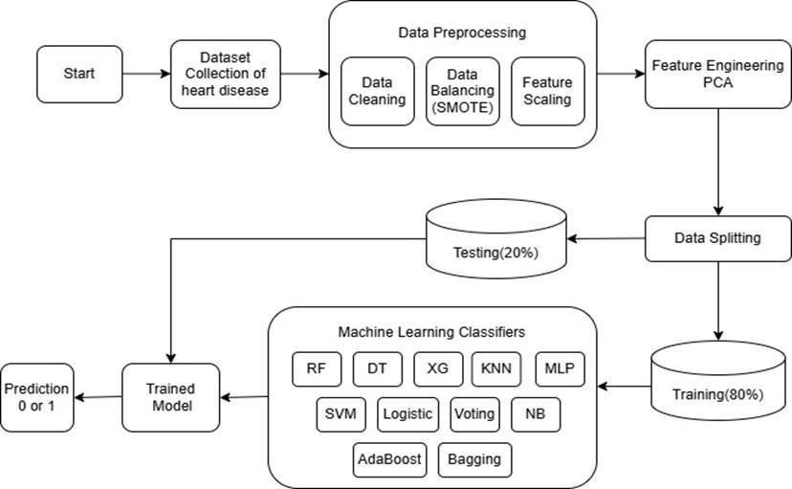

Fig. 5.1.1 System Architecture

To further enhance model interpretability, both SHAP (Shapley Additive Explanations) is used to highlight the importance of each feature into considerations for making decisions and LIME (Local Interpretable Model-Agnostic Explanations), which provides case-specific explanations, thus guaranteeing more transparency in AI-driven predictions and allowing medical experts to make informed decisions assisted by thorough insights into AI-based decisions models.

Data Flow Diagram:

- A bubble chart serves as the alternative name for the DFD. The simple graphical presentation allows system representation through its input data and processing operations and output data production.
- The data flow diagram (DFD) stands as an important modeling instrument for design applications. The modeling tool depicts the system's elements which are its process and the process data and the external actors who use it together with the information transfer paths inside the system.
- The DFD describes how the information is transformed as it is moved through the system. It is a graphic depiction of the movement of information as it is transformed during movement through the system from input to output.

UML Diagrams:

    - Class Diagram:

The class diagram functions to improve the use case diagram while establishing a thorough system design. The class diagram uses the actors from the use case diagram to generate an organized set of interconnected classes. Courses in a class diagram establish relationships that function as either inheritance relations or contains relations. All classes in this diagram possess one or more specific functionalities to offer. The class methods represent the functionalities offered by an individual class. Every class contains unique attributes in addition to its characteristics.
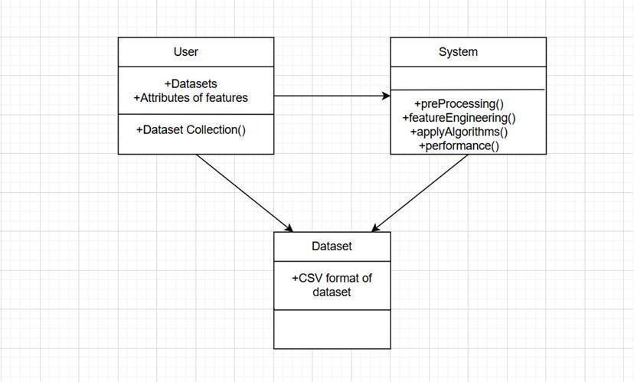

Fig. 5.3.1.1 Class Diagram

Use case Diagram:

The most recognized chart sort of the behavioral UML graphs, use case diagrams traces a realistic outline of the on-screen characters included in a framework, diverse capacities required by those on-screen characters and how these diverse capacities are relating. It‟s a magnificent beginning indicate for any describe discourse since you can effectively distinguish the fundamental performing artist included in any setting at the most vital levels and the primary forms the framework capacities by the way the performing artist connects with the framework.

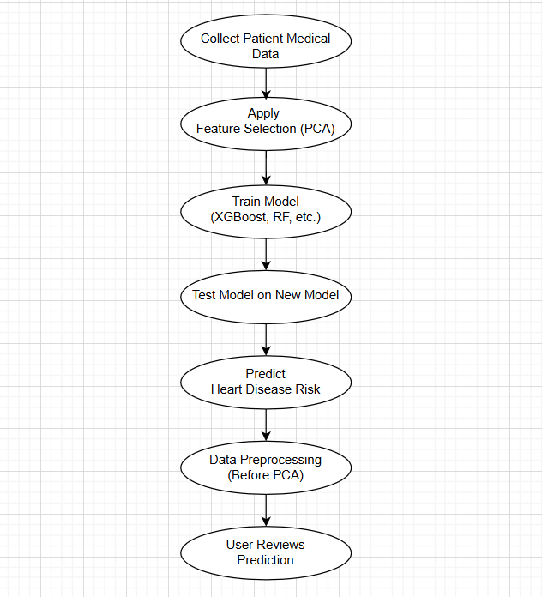

Fig. 5.3.2.1 Use case Diagram

Activity Diagram

Visual diagrams represent work processes in a graphical way. These diagrams display both business work processes and technical system component processes. Activities diagrams sometimes serve as replacement candidates for State machine diagrams.
- An activity diagram may also represent the process steps in performing a use case.
- Activity diagrams can be used to model sequential and concurrent activities. Therefore, as a graphical display, the workflow will be shown through an activity diagram.
- A modeling component called activity diagram visualizes process flows together with their activity order. An activity diagram depicts or represents what causes a particular event to transpire.

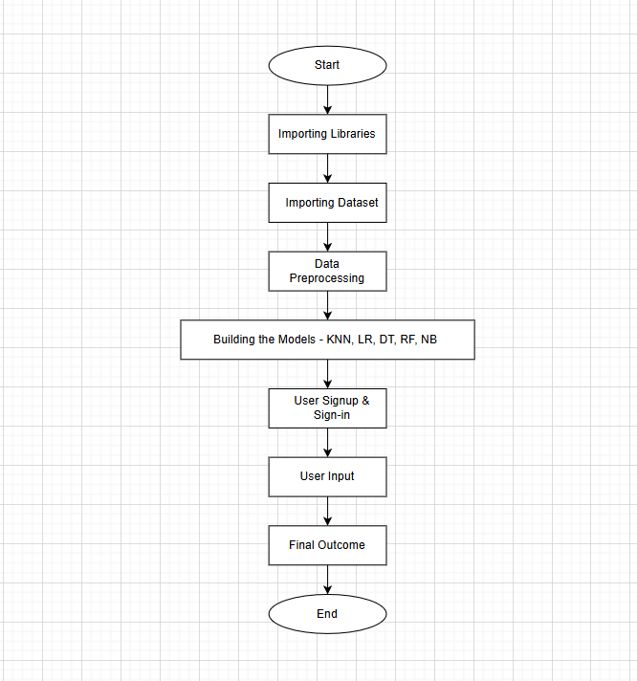

Fig 5.3.3.1 Activity Diagram
    - Sequence Diagram

UML sequence diagrams only depict object communications alongside the exact sequence of those exchanges. The definition of interactions plays an important role for a specific scenario. Each activity appears vertically in the model while arrows represent the interactions in this sequence pattern.

- Sequence diagrams have alternative names which include event diagrams and event scenarios.
- Sequence diagrams demonstrate how different system objects execute while indicating their operational sequence.
- The diagrams are widely employed by both business managers and software engineers to document system requirements for existing and new systems.

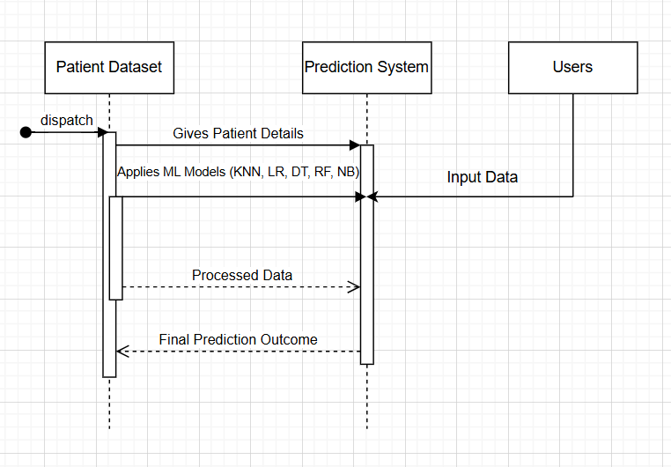

Fig 5.3.4.1 Sequence Diagram

5.3.4 Collaboration diagram

The collaboration diagram maintains interaction organization through object relationships just like interaction diagrams while additionally displaying these relationships at a collaboration level. Numbers in this sequence identify how events and communication flow between different system objects. This visual representation reveals the object connections thus enabling easier examination of system dynamic characteristics.
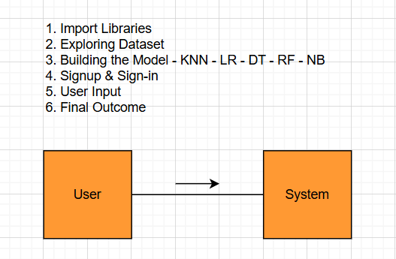

Fig 5.3.4.1 Collaboration Diagram

A collaboration diagram identifies every interaction which belongs to independent objects during their communication with other objects to establish comprehensive understanding of their combined functionality. It is particularly useful in designing and refining the object-oriented architecture of a system.

Data Flow Diagram

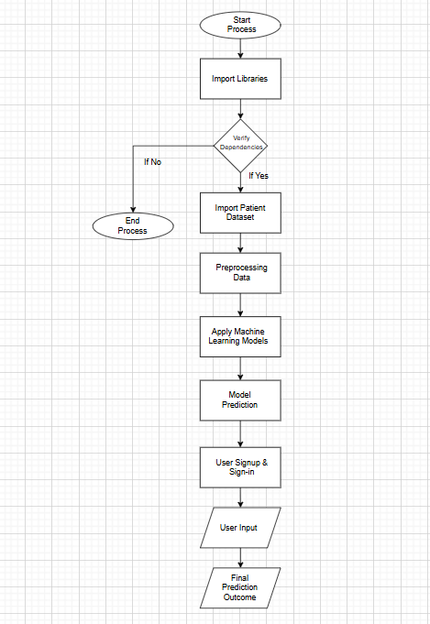

CHAPTER-6

SYSTEM REQUIREMENT SPECIFICATIONS (SRS)

SYSTEM REQUIREMENT SPECIFICATIONS(SRS)

Requirement Analysis:

The heart disease prediction system requires a user-friendly design to provide an easy method for users to enter health parameters. Users have to input several health factors during system operation including age, sex, blood pressure, cholesterol and smoking habits and others. The application must have different types of input methods and comprehensible instructions for each data field to guarantee accurate data entry by means of validation mechanisms and immediate feedback to improve user experience. A machine learning model will form the heart of this system and it will be employed in predicting risks associated with cardiovascular diseases basing on given parameters. For instance, the algorithms that might be used include Neural Network, Decision Tree and Logistic Regression approaches among others. There will also be an attempt to train the model using balanced data sets so that predictions do not favor any particular class by selecting features which are relevant to heart disease.

Software Requirement Specification:

The software development activity starts with Software Requirement Specification (SRS). It was realized as the system was growing in complexity that its entire purpose could not be easily understood. That is why the requirement phase is necessary. Client requirements are the start of a software project. The SRS functions as an interpreter from clients‟ mind (input) to output of necessity stage (which is a formal document). There addressing these specifications are subject to discussion during the activity, and principal attention is paid to specification of noticed features, representation and specification languages and tools, checking. The SRS document arises from this phase of production.
The purpose of creating Software Requirement Specification Decision Tree Based Heart Disease Prediction Using Machine Learning Algorithms is to minimize the gap in communication between developers and customers.

Functional Requirements:
- The main functional characteristic of this project requires forecasting heart disease development in patients who present specific symptoms.
- The main functional characteristic of this project requires forecasting heart disease development in patients who present specific symptoms.
- It will improve the accuracy and reduce the running time.

Non-Functional Requirements:
- The system receives medical data points of Blood pressure along with hypertension, diabetes and cholesterol measurements for data modeling purposes.
- Data Visualization tools apply to datasets to make it easy for users to detect data trends alongside outliers and establish patterns within the data.

Software Requirements:
- Operating System : Windows
- Programming : python 3.6
- Software : Anaconda
- Framework : React / Flask
- Development Enviroment : Google colab, Jupyter Notebook, AWS Cloud
- Libraries : Sklearn, Numpy, Pandas, Data processing

Hardware Requirements:
- Processor : intel core i5
- Ram : 16GB
- Processing unit : CPU

CHAPTER-7

SYSTEM IMPLEMENTATION

7.1 SYSTEM IMPLEMENTATION

Modules:

The Cardiovascular Disease Prediction and Classification framework relies on Machine Learning techniques that utilize different Python modules for its operation.

Introduction

Early diagnosis of heart disease proves vital for effective treatment because this condition stands as one of the world's primary death factors. Machine learning (ML) has proven to be a leading tool which uses medical data patterns to forecast heart disease. Various Python libraries assist in data processing, visualization, and building predictive models, enhancing accuracy and efficiency. This document explores key Python modules used in heart disease prediction, including Scikit- Learn, Pandas, NumPy, Matplotlib, and Seaborn, and their roles in developing a robust ML-based prediction system.

Scikit-Learn
Python developers choose Scikit-Learn since it stands as one of the most popular machine learning libraries that delivers straightforward and fast data mining and analytical tools.
- The programming library includes logistic regression and decision trees together with support vector machines and ensemble methods that are common to heart disease prediction tasks.
- The preprocessing functions of the library include feature selection along with scaling methods and model evaluation through cross-validation techniques to improve accuracy.

NumPy
- The general-purpose array processing package known as Numpy focuses on multidimensional arrays and their supporting tools. The package delivers a fast multidimensional array component together with array manipulations.
- It is the fundamental package for scientific computing with Python. It contains various features including these important ones:

- It supports mathematical operations, including statistical calculations and array manipulations.
- Often used alongside Pandas, NumPy enables vectorized operations on patient health data, improving computational efficiency.

Pandas:

- As an open-source Python Library this tool operates at high performance speeds for data manipulation and analysis with its strong data structure components. Data munging and preparation were the primary purposes of using Python in the dataset. The data analysis portion made minimal contribution through Pandas.
- Pandas solved this problem. Pandas enables users to perform the standard five data processing activities load, prepare, manipulate, model and analyze by regardless of data source. The Python-Pandas programming combination serves various academic and commercial spheres which include finance and economics and statistics alongside analytics etc.
- Pandas is a crucial data manipulation and analysis library designed for handling structured data, such as patient records.It provides data structures like DataFrames, making it easy to clean, filter, and transform medical datasets.Functions like read_csv(), groupby(), and describe() help explore patient health parameters, including blood pressure, cholesterol levels, and heart rate.

- It is the fundamental package for scientific computing with Python. It contains various features including these important ones:

- It supports mathematical operations, including statistical calculations and array manipulations.
- Often used alongside Pandas, NumPy enables vectorized operations on patient health data, improving computational efficiency.

Pandas:

- As an open-source Python Library this tool operates at high performance speeds for data manipulation and analysis with its strong data structure components. Data munging and preparation were the primary purposes of using Python in the dataset. The data analysis portion made minimal contribution through Pandas.
- Pandas solved this problem. Pandas enables users to perform the standard five data processing activities load, prepare, manipulate, model and analyze by regardless of data source. The Python-Pandas programming combination serves various academic and commercial spheres which include finance and economics and statistics alongside analytics etc.
- Pandas is a crucial data manipulation and analysis library designed for handling structured data, such as patient records.It provides data structures like DataFrames, making it easy to clean, filter, and transform medical datasets.Functions like read_csv(), groupby(), and describe() help explore patient health parameters, including blood pressure, cholesterol levels, and heart rate.

Matplotlib:
  - Matplotlib serves as a Python library which generates high-quality visuals across different hardware formats via interactive displays that support multiple operating systems. Matplotlib can be used in Python scripts, the Python and IPython shells, the Jupyter Notebook, web application servers, and four graphical user interface toolkits.
  - Matplotlib enables users to produce various plots together scatter plots and

error charts.

Scikit – learn:
- Python programmers use Scikit-learn as a single interface to numerous supervised and unsupervised learning algorithms. It is licensed under a permissive simplified BSD license and is distributed under many Linux distributions, encouraging academic and commercial use.

TensorFlow & Keras (Deep Learning Models)

Even though conventional machine learning algorithms work well, more complex models, like neural networks, can be created with the help of sophisticated deep learning frameworks like TensorFlow and Keras.
- Such libraries enable the training process across large datasets to discover hidden patterns which achieves better prediction results.
- Both Convolutional Neural Networks (CNNs) and Recurrent Neural Networks (RNNs) provide solutions for extracting valuable features as well as analyzing sequences of information.

Development Environment:
    - Python:
Rapid Application Development benefits from Python because this dynamic object- oriented language uses high-level data structures together with dynamic types and binding capabilities. This language functions for programming purposes as well as item connection functions. The fundamental Python syntax enables basic code learning for users. Readability serves as the main focus of Python which results in lower program maintenance expenses. The ability to use modules and packages in Python enables programmers to divide their code into smaller parts while maintaining code reusable elements. You can obtain the Python engine together with its extensive standard library free of charge through code or binary format and you can distribute them to everyone. A lot of the time, coders fall in love with Python because it helps them get more done. The loop of change, test, and fix is very fast because there is no assembly step. It's easy to find bugs in Python programs because asegmentation fault can't be caused by a bug or

bad data. Instead, an exception is raised by the translator when it finds a mistake. A stack trace is shown by the processor when the computer doesn't catch the bad code.
Writing code for the debugger in Python is an example of self-analysis. Adding print lines to source code is often the easiest way to make a program better because it makes changing, testing, and fixing go faster. As a dynamic and high-level open-source language Python provides users with free code writing capabilities for both object- oriented and procedural programs. The lack of variable types allows Python to handle the data type of x independently whether it represents a string or number.
Python stands out due to its extensive collection of standard libraries designed to execute the following functions:
      - GUI Applications (like Kivy, Tkinter, PyQt, etc. )
      - Django represents a web framework which powers applications from YouTube to Instagram as well as Dropbox.
      - Image processing (like Opencv, Pillow)
      - Applications used for web information extraction consist of Scrapy along with BeautifulSoup and Selenium.
      - Test frameworks

History of Python:
Python shares initialism characteristics with both the alphabet and the programming language. Right, both start with ABC. The programming language ABC stands as the topic when discussing ABC in the context of Python. ABC applies as a general-purpose programming language together with its accompanying programming environment through development at CWI (Centrum Wiskunde &Informatica) in Amsterdam Netherlands. ABC stands as the most significant achievement by becoming the basis for Python's development. The creation of Python took place during the late 1980s period. Guido van Rossum participated in Amoeba development at the CWI when he worked during that period. According to an interview with Bill Venners1 Guido van Rossum stated that during the early 1980s he worked as an implementer with a team developing the ABC language at Centrum voor Wiskunde en Informatica (CWI). The level of ABC's

impact on Python remains uncertain to most people. Van Rossum acknowledges ABC's contributions because he received all his knowledge from working on this project while also showing gratitude toward the team members involved.

Features of Python: Easy to Read, Learn and Write:
The Python programming language operates at a high-level through syntax that resembles English communication. The code becomes more readable because of its English-like syntax structure. Python stands out because it has an approachable learning curve which makes it suitable for new programmers according to many sources.

Improved Productivity:
The productivity levels of Python remain very high. The basic nature of Python allows programmers to concentrate on problem solution. The programmers can skip spending long hours studying how the programming language behaves or which syntax rules apply.

Interpreted Language:
Python serves as an interpreted language that executes programming instructions directly one after another. The interpreter detects errors while programming so it immediately pauses execution to return copied mistakes. Python makes debugging easier.

Dynamically Typed:
Python requires us to execute the code to determine variable data type. The language system determines data types during its running process. Programmers do not require additional work to specify variable definitions or assign data types within their code.

Free and Open-Source:
The open-source license approved by OSI applies to Python. Users and distributors can utilize the software without paying and they can spread it without cost. Every Python user has access to download its original source code followed by the ability to modify it and distribute their customized version of the programming language. Organizations which need to develop their own version of behavior for development purposes can find

this approach beneficial.

Advantages of Python:

Extensive Libraries:
Python downloads provide extensive libraries which enable users to create various codes including regular expressions along with documentation generation and unit testing features in addition to web browsers and threading databases and CGI and email capabilities and image manipulation functions. Because of this we do not need to generate the entire code manually.

Highly Extensible:
Contrary to most programming languages Python remains accessible to C/C + due to which high-performance modules can exist in C while Python controls all other code.

Embeddable for Flexibility:
Python enables a developer to place Python code directly into the source code of connected languages like C. With this ability developers maintain full access to strong scripting functionality while writing their code.

Excellent for IoT Development:
The combination between Python and Raspberry Pi enables young developers to work on Internet of Things (IoT) solutions because Python offers easy implementation and high adaptability when linking software to hardware for developing innovative new options.

Simple and Beginner-Friendly:
Python excels as a programming language by offering simple code syntax which improves both writing and learning code tasks. Java needs a special class structure to display ”Hello World” but Python reaches this result through one print() function. The basic foundation of Python syntax selects it as the preferred coding language.

AWS account creation:

Go to AWS Website
Visit AWS Sign Up and click on “Create an AWS Account”



Fig 7.2.5.1 AWS free tier Web page

Account Setup
Enter your email address, create a password, and provide an account name.
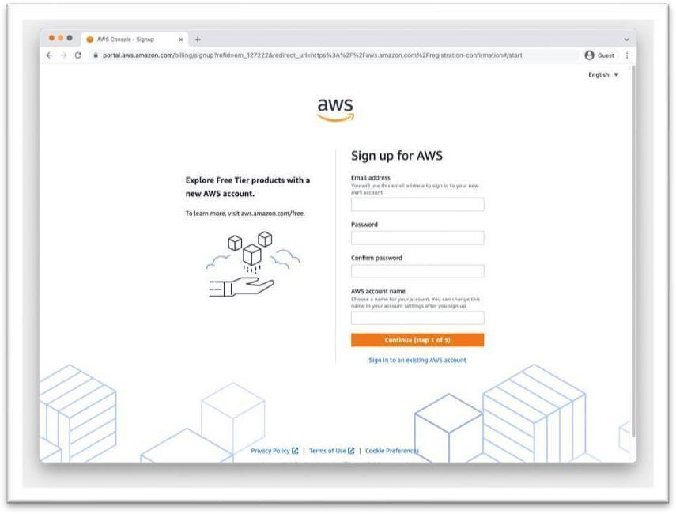

Fig 7.2.5.2 AWS account sign in page

Billing Information:

Aws requires valid credit/debit card details.
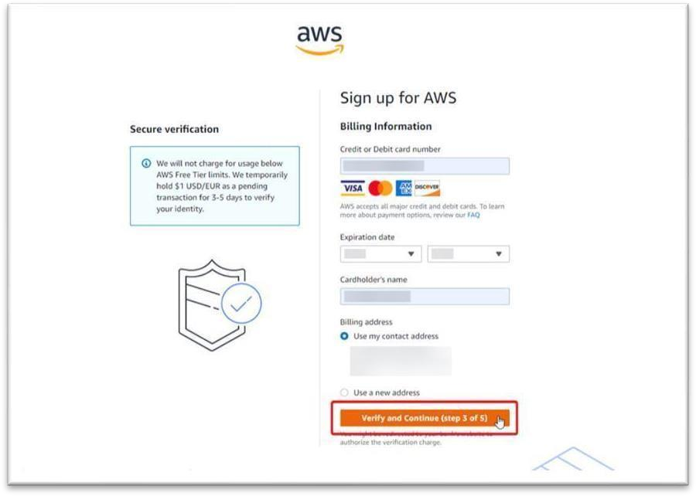
Fig 7.2.5.2 AWS Sign up: Billing Information page

Identity Verification:
AWS verifies your identity via phone call or SMS.


Fig 7.2.5.4 AWS Signup: Identity verification page

- Select Support Plan
- Choose the basic Support plan(Recommended for new Users)
- Login to AWS Console
- Use your registered credentials to access the AWS Management Console
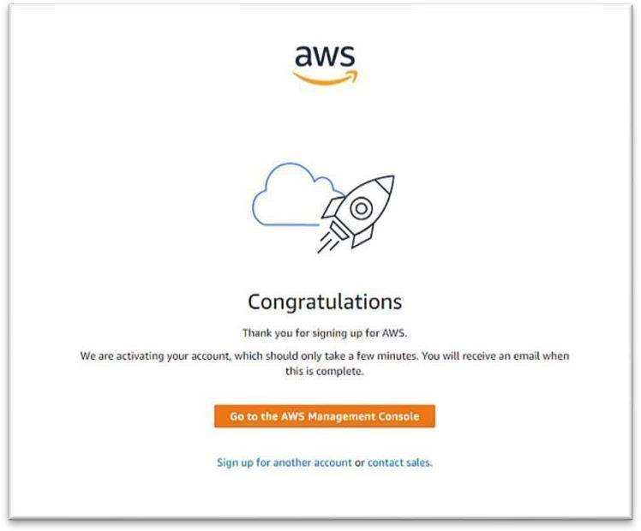

Fig 7.2.5.5 AWS Signup: Account activation confirmation page

Exploring the AWS Management Console

Exploring the AWS Management Console The AWS Management Console is a web- based interface that allows users to manage their AWS resources easily. For the DeepSkin project, two key services are utilized: Amazon S3 (Simple Storage Service): A secure, scalable storage service used to store and retrieve dermoscopic images for skin cancer classification. It offers high durability and availability, ensuring that medical data is safely stored and easily accessible. Amazon SageMaker: A comprehensive service designed to build, train, and deploy deep learning models. In the HeartHealth AI project, SageMaker is used to implement machine learning models such as XGBoost, Random Forest, and MLP classifiers for accurate heart disease prediction.

From data preprocessing to model deployment, it optimizes the machine learning process. The system makes early cardiovascular disease detection more dependable and accessible by utilizing AWS services to guarantee effective data storage, smooth model deployment, and increased scalability.

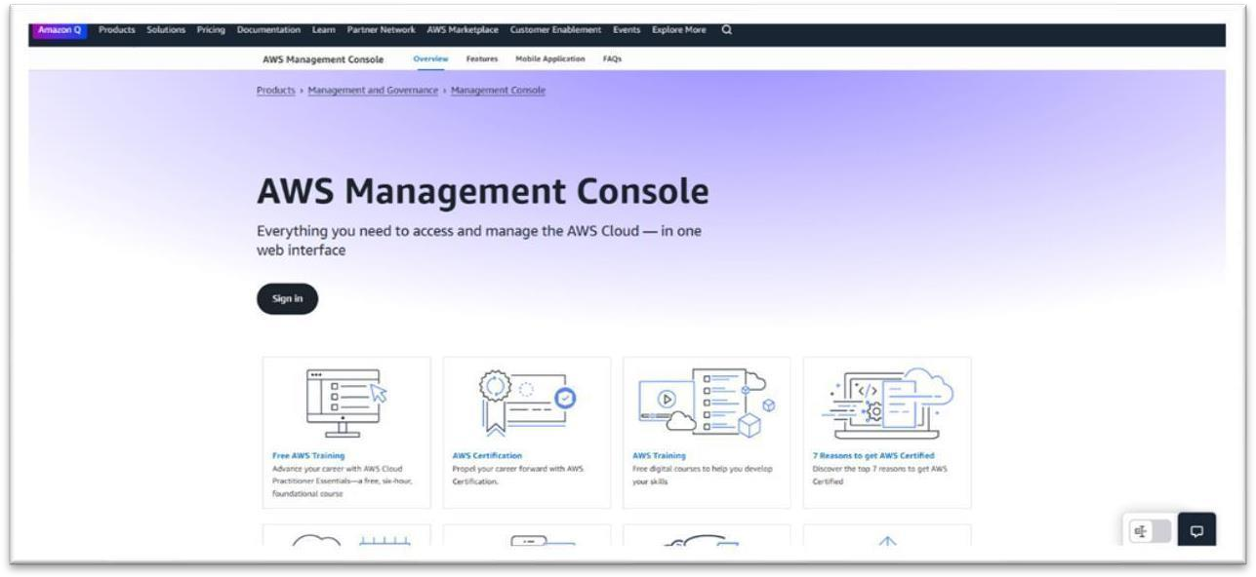
Fig7.3.6.1 AWS Management Console Webpage

Amazon S3 for Data Storage Definition:
Amazon S3 (Simple Storage Service) is a secure, scalable, and durable cloud storage service provided by AWS. It is widely used for storing data, backup solutions, and integrating with services like Amazon SageMaker for machine learning tasks.

Creating an S3 Bucket:
- Log in to your AWS account.
- In the AWS Console, search for "S3" and select the service.
- Click the "Create Bucket" button.
- Fill in the following details:
  - Bucket Name: Provide a globally unique name.
  - Region: Select the region closest to your users.

- Enable "Block All Public Access" for security purposes.
- Click "Create Bucket" to complete the setup.

Uploading Project Files to Your S3 Bucket:
- Open your newly created bucket.
- Click the "Upload" button.
- Drag and drop your project file (a 630 MB ZIP file) or use the "Add Files" option to select the file.
- Click "Upload" to complete the process

Purpose in Your Project:
The uploaded 630 MB ZIP file contains essential data required for your Heart Disease Prediction Model.
This data will be accessed directly by Amazon SageMaker for model training, ensuring efficient integration and seamless processing.

Advantages of Amazon S3 for Your Project:
Scalability: Can store large datasets like your 630 MB ZIP file efficiently.
Data Security: Ensures your data is protected through encryption and access control.
Reliability: Guarantees data availability for SageMaker integration during model

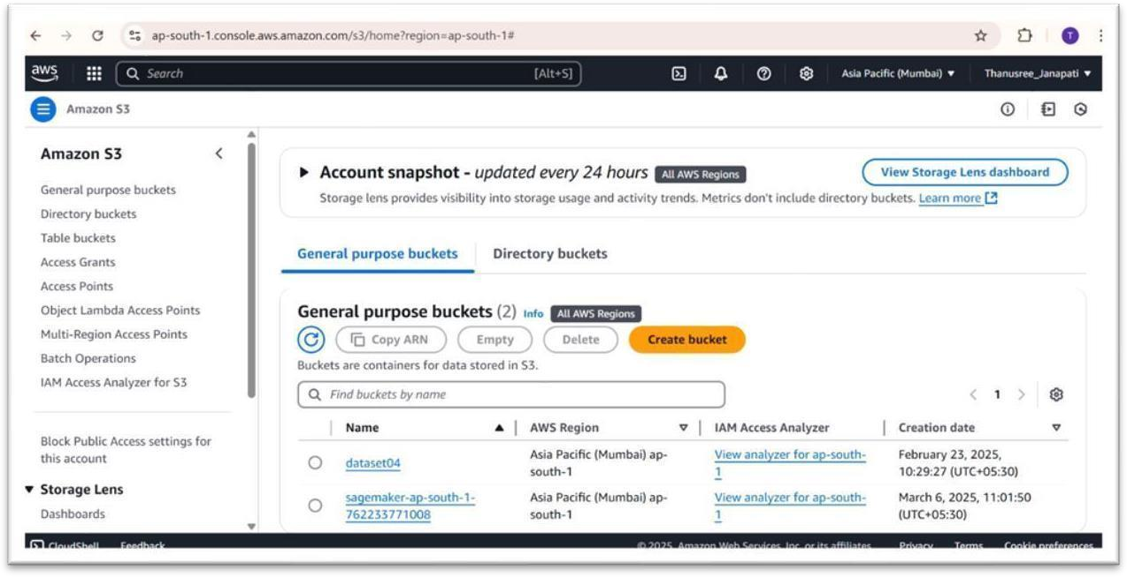
Fig 7.3.7.1 AWS S3 console interface

Amazon SageMaker for Model Deployment:
Amazon SageMaker is a fully managed service that enables developers and data scientists to build, train, and deploy machine learning models efficiently. It streamlines the ML workflow by providing tools for data preparation, model training, and deployment.

Creating a SageMaker Notebook Instance:
- Log in to your AWS account.
- In the AWS Console, search for "SageMaker" and select the service.
- Navigate to Notebook Instances and click "Create Notebook Instance."
- Provide the following details:
  - Notebook Name: Example: MyModelDeployment
  - Instance Type: Choose ml.g4dn.xlarge (recommended for GPU- based model training to improve performance).
  - IAM Role: Click "Create New Role" and select S3 Full Access to ensure SageMaker can access your stored data.

- Click "Create Notebook Instance" to complete the setup.

Uploading Your Model Files to the SageMaker Notebook:
- Once the status changes to Inservice, click "Open Jupyter" to launch the Jupyter environment.
- Inside the Jupyter interface:
- Click the "Upload" button
Select your model file(s) or dataset from your local system. Click "Upload" to add the files to the notebook environment.

Purpose in Your Project:
In your Heart Disease prediction Model, SageMaker will access the uploaded data (stored in Amazon S3) to train and deploy the model. The notebook environment allows you to write and run code for data preprocessing, model training, and evaluation.

Advantages of Amazon SageMaker for Your Project:

- High Performance: The ml.g4dn.xlarge instance leverages powerful GPU capabilities for faster model training and improved accuracy.
- Seamless Integration: Easily connects with Amazon S3, ensuring efficient data flow.
- Scalability: Adapts to varying data sizes and computational needs.

This structured approach ensures efficient model deployment while optimizing performance using the ml.g4dn.xlarge instance.

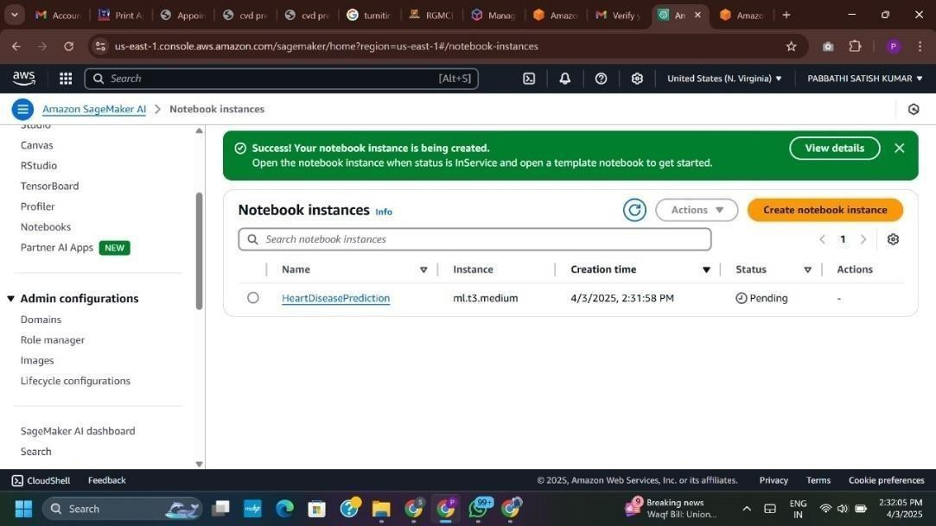
Fig 7.3.8.1 AWS SageMaker Notebook instances console

Deploying and Managing the Model in Amazon SageMaker Deploying Your Model in SageMaker:
To deploy your Heart Disease Prediction Model, you will first need to create an endpoint configuration in Amazon SageMaker. In the AWS SageMaker console, navigate to the Inference → Endpoints section. Click "Create Endpoint Configuration" and provide the necessary details, such as an appropriate Endpoint Name (e.g., Deployed_Model) and select your model stored in Amazon S3. Choose a suitable instance type like ml.m5. large for optimal performance. Once the details are filled in, click "Create Endpoint Configuration" to proceed.
Next, return to the Endpoints section, select your newly created endpoint configuration, and click "Create Endpoint" to initiate deployment. After confirming, the endpoint will be created, and its status will change to Inservice once it's live and ready for predictions. This endpoint allows your model to make real-time inferences efficiently.

Accessing the Deployed Model:
Once your model endpoint is active, navigate to the Endpoints section in SageMaker and copy the provided Endpoint URL. This URL will follow a structure similar to: https://<endpoint- url>/invocations

To send requests for predictions, you can use tools like Postman or write custom Python scripts to send HTTP requests to this endpoint.
This method ensures easy and secure access to your model's inference capabilities.

Monitoring and Managing Your Deployment:
Using Amazon CloudWatch is the simple way to check how your deployed model is performing and its stability. CloudWatch gives you metrics of usage on the endpoint, such as metrics for request count, latency, and error rates. For auditing and security purposes, use AWS CloudTrail, which enables users to log AWS API calls and provide a transparent record of the access and usage in your AWS account.

Monitoring Cost and Usage:
To manage cost, review your AWS Billing Dashboard regularly to look for unexpected AWS charges. You will also want to review your CloudWatch Alarms to see if anything triggered an alarm as well. In the event of a usage spike, using CloudWatch will help you monitor it so you can take action in a timely manner. Always make sure to shut down SageMaker Notebook Instances that you are not using to save on cost. In general, you'll want to delete SageMaker Notebook Instances, S3 Buckets, and Endpoints once you are finished with them to prevent ongoing charges.

Best Practices for AWS Deployment:
To ensure overall security, the principle of least privilege should be applied to AWS Identity and Access Management (IAM) roles. This means use an IAM role with as limited permissions as possible for added security. Regularly back up critical project data in Amazon S3, to mitigate potential data loss. You may want to implement S3 Lifecycle Policies to minimize storage cost by transitioning your data to lower cost storage classes. Setting CloudWatch Alarms enables you to research any unusual activity or behavior you observe, improving system security and stability.

Final Checklist for AWS Deployment:
Once you are ready to consider your deployment complete, please verify the following:

- AWS account configuration is complete

- Data uploaded to Amazon S3.
- SageMaker Notebook Instance is created and functioning.
- The model is uploaded and an endpoint is created and tested.
- CloudWatch and CloudTrail are configured for monitoring system activity.
- Costs are audited and optimizations for resource usage have been taken into account By following these organized methods, your Heart Disease Prediction Model will have been deployed, available for real-time predictions, and the AWS resources monitored effectively for performance as well as cost.

Conclusion:
Manually deploying your project to AWS services like S3 and SageMaker is a powerful way to access scalability, security, and flexibility all with minimal need for complex Python code. By following these steps, you have established a strong system that leveraged AWS infrastructure to support your project and allows it to run efficiently.

Component | Specification
OS | Windows(64 – bit)
Processor | Intel Core i5
RAM | 8 GB
Storage | 25 GB free space

Sample Code

Below are the screenshots showcasing the code implementation for Heart Disease Prediction within the project framework.

Importing the required packages:
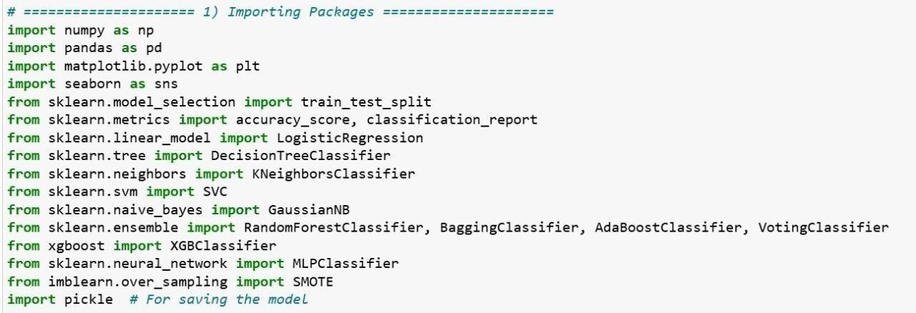
Fig 7.4.1 Importing Packages

Loading the sample data
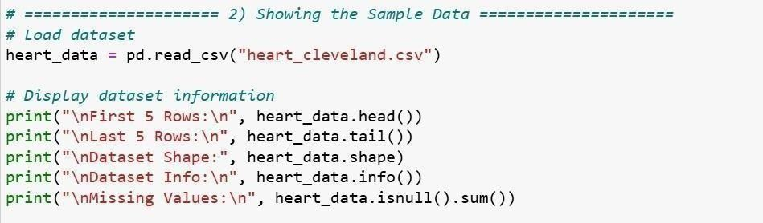

Fig 7.4.2 Loading the sample data

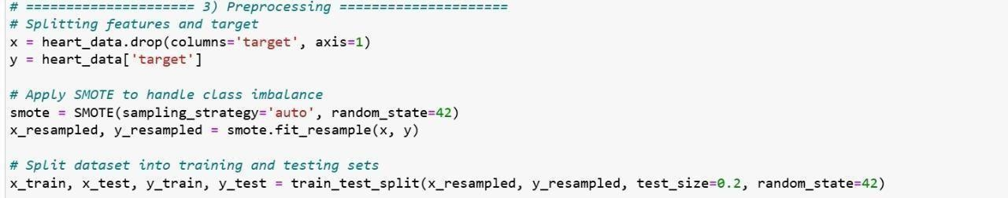

Data Preprocessing

Fig 7.4.3 Data Preprocessing

Preparing the data for Training and Testing:
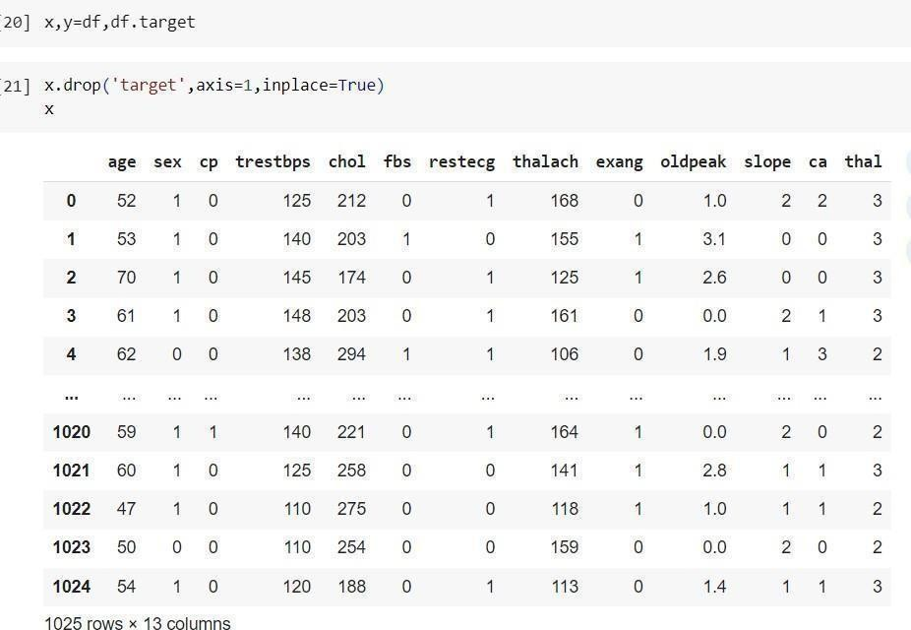
This data set is disconnected into planning and testing data sets. The data is arranged by giving particular highlights of program and as well the abdicate which is whether a bug is appear or not.

When the planning is done at that point the system is attempted by giving particular highlights of computer program to the system so that it predicts the bug in the program. Portion data into planning and testing is done by utilizing the Sklearn bundle which comprises of train_test_split work which parts clusters into sporadic plan and test subsets. In the amplify the data set is splitted into 80% of planning data and 20% of testing data.
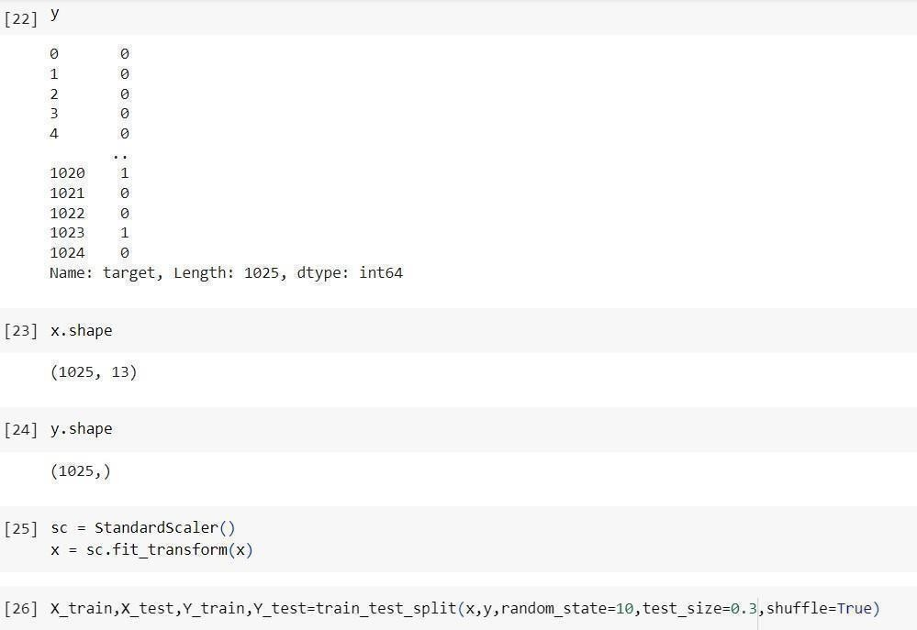
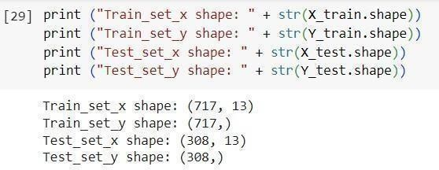

Fig: 7.4.4 Splitting the data set into training and testing

Features Selection:
Feature Selection is the get ready of reducing the number of input variables when making a prescient illustrate. It is appealing to diminish the number of input variables to both decrease the computational taken a toll of modeling and, in a few cases, to make strides the execution of the appear.

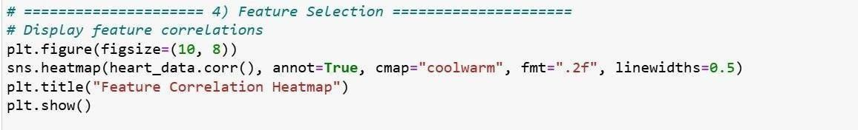
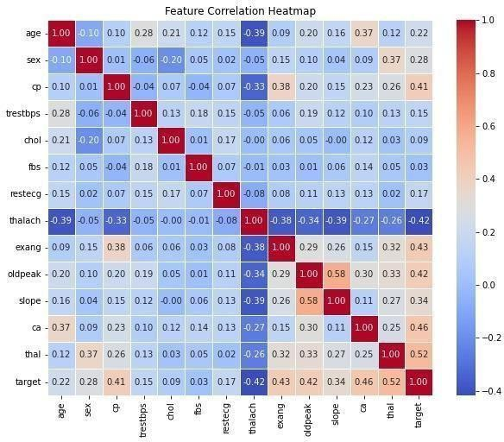
Fig 7.4.5 Feature Selection

Data Visualization
Displaying data or information in graphs, charts, or other visual formats is called data visualization. For example, machine learning can simplify predictive analytics and provide useful visual representations
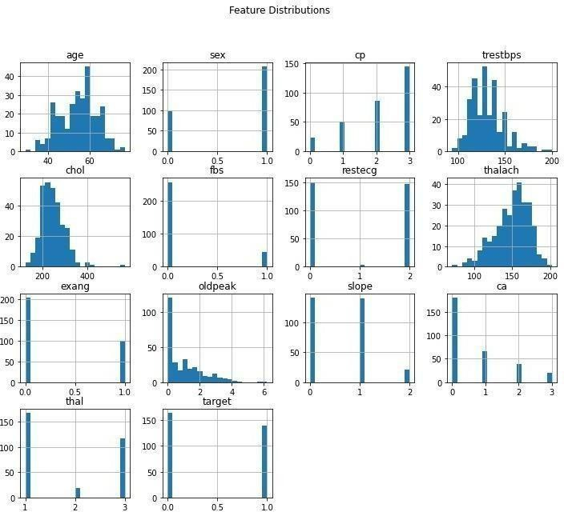

Fig 7.4.6 Data Visualization

CHAPTER-8 RESULTS AND ANALYSIS

RESULTS AND ANALYSIS

Evaluation Metrics:

We took a close look at how various networks performed on the testing dataset once the training phase wrapped up. To make a fair comparison, we used six important performance metrics: accuracy, sensitivity (also known as recall), specificity, precision (or positive predictive value), the area under the curve (AUC), and the F1 score.

Accuracy is a key metric that tells us how often the model gets it right overall. It provides a broad understanding of how effectively the model identifies both positive and negative cases. For instance, if a model predicts heart disease accurately, it should classify both diseased and non-diseased cases correctly. However, relying solely on accuracy can mask errors in detecting minority classes.
Accuracy = (TP + TN) / (TP + TN + FP + FN)
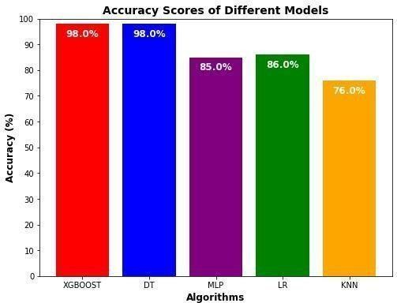

Fig 8.1.1 Classification performance Comparison of Accuracy Score

Precision: Precision indicates how often the model correctly identifies positive cases out of all the cases it predicts as positive. It highlights the model's ability to avoid false positives. In medical contexts, high precision means that when a patient is diagnosed with heart disease, they truly have it. Low precision, on the other hand, suggests that the model is misdiagnosing many healthy patients as having heart disease. Reducing false positives is crucial to avoid unnecessary medical interventions, so improving precision enhances the reliability of diagnoses
Precision = TP / (TP + FP)
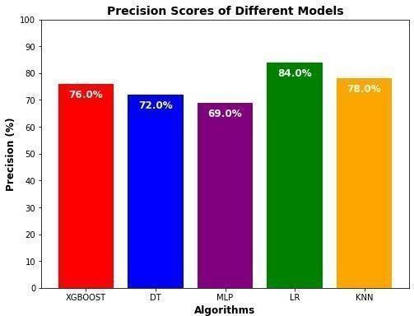

Fig 8.1.2 Classification performance comparision of precision score

Recall: Recall measures how well the model finds all the actual positive cases. It demonstrates the model's ability to detect positive cases, minimizing the risk of false negatives. A model with high recall is more likely to catch most individuals with heart disease. However, achieving high recall often leads to an increase in false positives. Therefore, it's essential to find a balance between recall and precision to create an effective medical prediction model.
Recall = TP / (TP + FN)

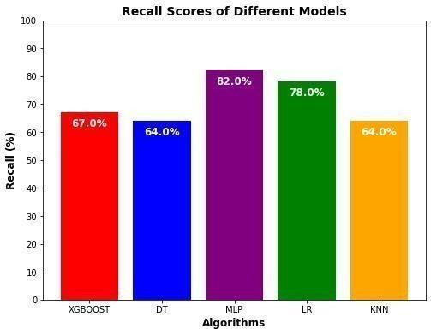

Fig 8.1.3 Classification performance Comparison of Recall Score

F1 Score: The F1 score combines precision and recall into a single metric, providing a balanced assessment of the model's performance. It's like having a single score that considers both how often the model correctly identifies positive cases and how often it finds all the actual positive cases.
f1_score = 2 * (precision * recall) / (precision + recall)
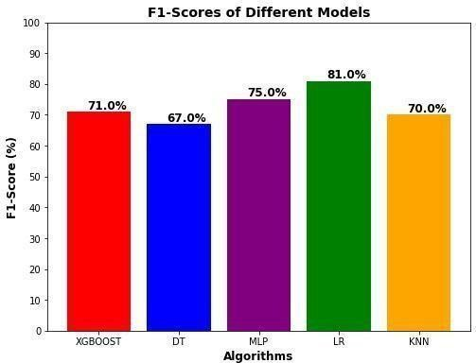

Fig 8.1.4 Classification performance Comparison of F1 Score

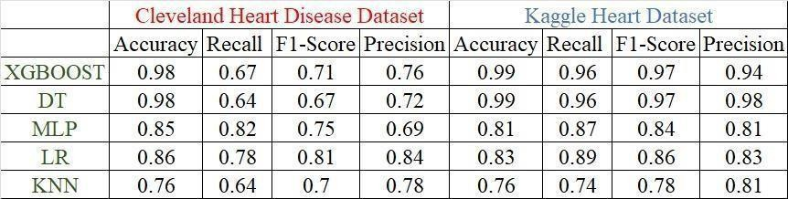

Table-2: Performance Evaluation of Heart Disease

  - Screenshots:
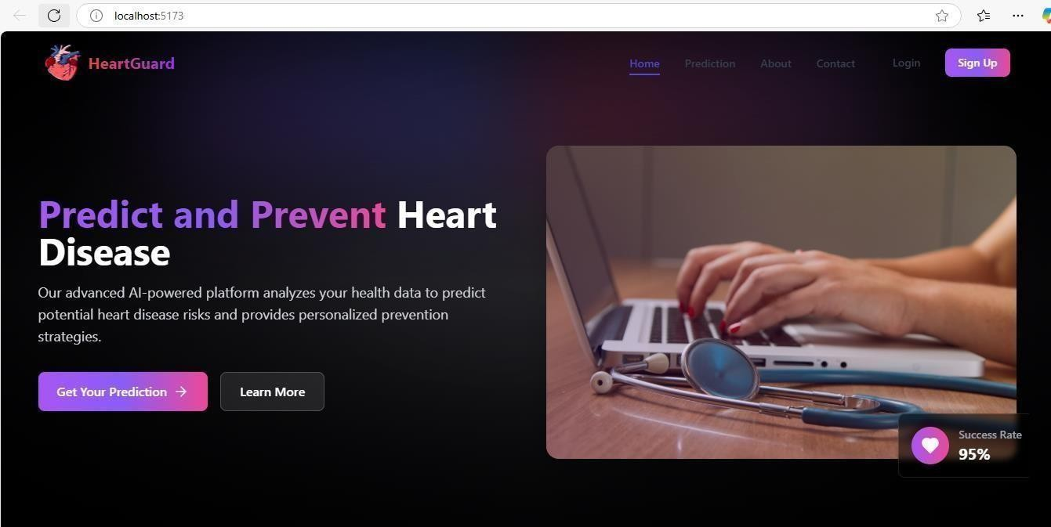
Fig. 8.2.1 Homepage

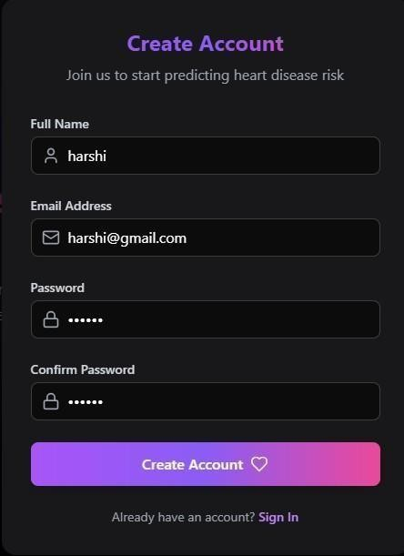

Fig 8.2.2 Sign up page


Fig 8.2.3 Login Page

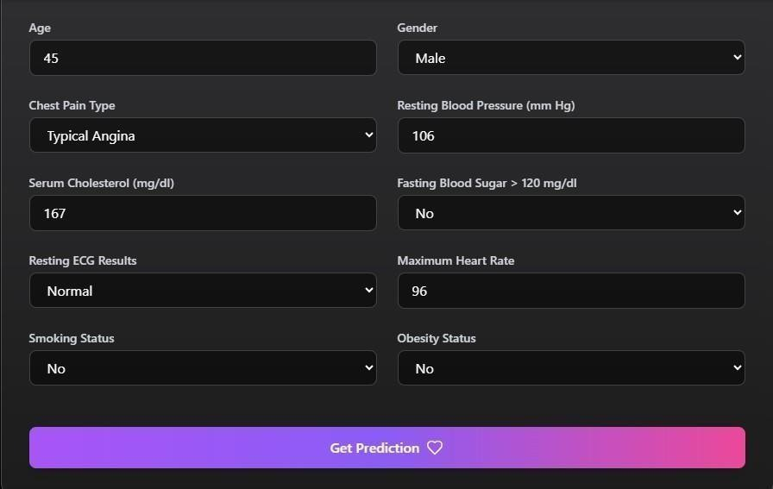

Fig. 8.2.4 Heart Disease Detection Input
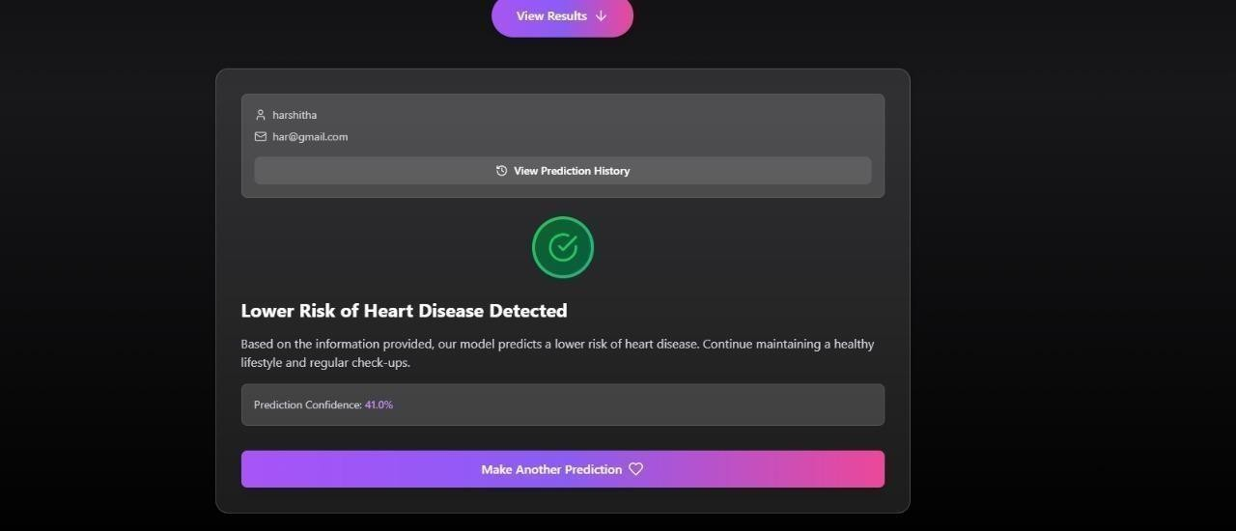

Fig. 8.2.5 Heart Disease Detection Output

CHAPTER-9 SYSTEM TESTING

SYSTEM TESTING

The main goal of testing is to uncover any errors. It involves a thorough examination to identify every possible flaw or weakness in a product. Testing allows us to verify how well components, sub-assemblies, assemblies, and the final product function. Essentially, it’s about putting the software through its paces to make sure it meets all the necessary requirements and user expectations, while also avoiding any unacceptable failures. There are different kinds of tests, each designed to tackle a specific testing need.

Need for Testing:

Testing is all about spotting errors. It plays a crucial role in quality assurance and helps ensure that software is reliable. The outcomes of testing are important for maintenance down the line.

Psychology of Testing
The goal of testing is often to prove that a program functions correctly by demonstrating that it has no errors. Essentially, the main purpose of the testing phase is to identify any errors that might be lurking in the program. So, instead of starting testing with the mindset of proving that a program works, the focus should be on showing that it doesn’t work. Testing involves running a program with the aim of finding errors.

Testing Objectives
The primary goal of testing is to uncover a variety of errors efficiently and with minimal effort. To put it formally, we can say:
    - Testing is the act of running a program with the goal of finding errors.
    - A successful test is one that reveals an error that hasn’t been discovered yet.
    - A good test case is one that has a high chance of finding an error, if there is one.
    - The tests may not be sufficient to catch all potential errors.
    - The software meets quality and reliability standards.

Levels of Testing

To identify errors that may arise during various phases, we rely on the concept of levels of testing.

System Testing

The main goal of testing is to uncover errors. With this objective in mind, we create specific test cases. One effective strategy for system testing is code testing.

Code Testing

This approach focuses on analyzing the program's logic. To implement this method, we generate test data that allows us to execute every instruction within the program and its modules, ensuring that every possible path is tested. It's important to note that systems are not designed or tested as a whole; instead, we perform two types of testing to guarantee that the coding is flawless across all systems.

Types of Testing:
Unit testing
Unit testing is all about creating test cases that ensure the internal logic of a program is working as it should and that the inputs lead to the right outputs. It’s crucial to validate all decision branches and the flow of code inside. This type of testing happens after a unit is completed but before it gets integrated with other parts of the application. It’s a structural form of testing that requires a good understanding of how the unit is built, making it somewhat invasive. Unit tests focus on basic checks at the component level, targeting specific business processes, applications, or system configurations. They make sure that every unique path in a business process operates correctly according to the documented specifications, with clearly defined inputs and expected results.

Integration testing
Integration testing, on the other hand, is all about checking how well integrated software components work together as a single program. This testing is event-driven and focuses more on the overall outcomes of screens or fields. Integration tests show that while each component may have passed unit testing successfully, it’s essential to

eensure that when combined, they function correctly and consistently. The goal here is to uncover any issues that might arise from the interaction between different components.

Functional test
Functional tests take a systematic approach to demonstrate that the functions being tested are available as outlined by business and technical requirements, system documentation, and user manuals. Functional testing revolves around a few key areas:
- Valid Input: Classes of valid input should be accepted.
- Invalid Input: Classes of invalid input should be rejected.
- Functions: Identified functions need to be exercised.
- Output: Classes of application outputs must be tested.
- Systems/Procedures: Interfacing systems or procedures should be invoked.
When organizing and preparing functional tests, the focus is on requirements, key functions, or any special test cases that need attention.

System Test

System testing is all about making sure that the entire integrated software system meets the necessary requirements. It checks a configuration to guarantee that the results are known and predictable. A good example of system testing is the configuration-oriented system integration test. This type of testing relies on process descriptions and flows, focusing on pre-driven process links and integration points.

White Box Testing

White Box Testing is a method where the software tester has insight into the internal workings of the software. This approach allows testers to examine the code and logic behind the application, making it possible to test areas that might be inaccessible through a black box perspective.

Black Box Testing

Black Box Testing involves evaluating the software without any knowledge of its internal structure, workings, or language. Like most testing methods, black box tests

should be based on a clear source document, such as specifications or requirements. In tthis approach, the software is treated as a black box, you can't see inside it. Instead, you provide inputs and observe outputs without considering how software operates.

Unit Testing

Unit testing typically takes place during a combined code and unit test phase in the software lifecycle, although it’s not unusual for coding and unit testing to be carried out as separate phases.

Test Strategy and Approach

Field testing will be done manually, and functional tests will be detailed in writing.

Test Objectives:
- All field entries must function correctly.
- Pages should activate from the specified link.
- The entry screen, messages, and responses must be prompt.

Features to be Tested:
- Ensure that entries are in the correct format.
- No duplicate entries should be permitted.
- All links should direct the user to the appropriate page.

Integration Testing
Software integration testing involves gradually bringing together two or more software components on a single platform to identify any failures that might arise from interface issues. The main goal of integration testing is to ensure that these components or software applications- whether they’re parts of a larger software system or applications used across the company- work together smoothly and without any errors.

Test Results: All the test cases listed above were successfully passed. No defects were found.

Acceptance Testing
User Acceptance Testing is a vital stage in any project, and it calls for substantial involvement from the end user. This phase also guarantees that the system aligns with the functional requirements.

Test cases:

SNO | INPUT | IF  AVAILABLE | IF NOT  AVAILABLE
1 | User signup | User get registered into the application. | There is no process.
2 | User sign in | User get login  into the application. | There is no process.
3 | Enter input for prediction | Prediction results displayed | There is no process

CHAPTER-10 SYSTEM STUDY

SYSTEM STUDY

In this phase, we take a close look at the project's feasibility and present a business proposal that outlines a broad plan along with some cost estimates. During the system analysis, we conduct a feasibility study to ensure that the proposed system won't become a burden for the company. To carry out this feasibility analysis, it's crucial to have a solid understanding of the main requirements for the system.
There are three key factors we consider in the feasibility analysis:
- Economical feasibility
- Technical feasibility
- Social feasibility

Economical Feasibility
This study focuses on assessing the economic impact the system will have on the organization. The funds available for research and development are limited, so we need to ensure that the expenses are justified. The developed system must stay within budget, which is achievable since most of the technologies we use are freely available. We only need to purchase customized products.

Technical Feasibility
Here, we evaluate the technical requirements of the system. Any system we develop should not place excessive demands on the available technical resources. High demands can lead to challenges for the client. Therefore, the system should have modest requirements, ideally needing minimal or no changes for implementation.

Social Feasibility
This aspect examines how well the users will accept the system. It includes training users to operate the system effectively. Users should feel comfortable with the system, viewing it as a valuable tool rather than a threat. The level of acceptance hinges on how well we educate users about the system and help them become familiar with it. We aim to boost their confidence so they can provide constructive feedback, which is always appreciated.

CHAPTER-11 CONCLUSION AND FUTURE SCOPE

CONCLUSION AND FUTURE SCOPE

Summary of findings:
To wrap things up, we created a heart disease prediction system that leverages machine learning algorithms to accurately determine whether patients have heart disease based on their medical features. We dedicated a significant amount of time to preprocessing the data, addressing missing values, scaling features, and using SMOTE to balance the dataset, all to enhance the model's performance. We explored a range of machine learning models, including Logistic Regression, SVM, Decision Tree, Random Forest, XGBoost, AdaBoost, Bagging, KNN, Naïve Bayes, and Voting Classifier, and evaluated them using metrics like accuracy, precision, recall, F1-score, and ROC-AUC. Out of all the models we tested, XGBoost and Random Forest emerged as the top performers, showcasing the highest accuracy and reliability, making them ideal for predicting heart disease risk. Our findings highlighted the importance of feature selection and ensemble methods, which significantly improved the model's generalization. The system is capable of processing new patient data and delivering real-time predictions along with a confidence score, aiding in early diagnosis and preventive measures. The results and visualizations we gathered during the evaluation confirmed that machine learning can effectively support clinical decision-making, reducing the need for manual intervention and improving diagnostic accuracy. This project lays the groundwork for integrating AI into healthcare, promoting data-driven approaches for early disease detection.

Limitations:

Data Availability and Quality:

The accuracy of the heart disease prediction system really hinges on the quality and availability of medical data. If the data set has missing values, biases, or imbalanced classes, it can seriously affect how well the model performs. Poor access to vast and varied medical records may diminish the system's generalizability. Human mistakes and inconsistency in medical data could add noise, affecting the prediction. Maintaining high- quality and well- labeled data sets is important to enhance model reliability.

Generalization to Real-World Data:

Machine learning systems can find it difficult to generalize to actual clinical data owing to differences in patient populations and medical conditions. Uncontrolled variation in data collection practices and hospital procedures can influence predictive accuracy. Large-scale validation on real-time hospital data is essential for better reliability. Scaling the system to various healthcare settings is still challenging.

Feature Engineering Challenges:

Choosing the most appropriate medical features for heart disease prediction is intricate and involves domain knowledge. Certain key features could be absent or are not present in the dataset, impacting model performance. Incorrect feature selection can result in overfitting or compromised accuracy in real-time environments. Advanced methods such as automated feature selection would be useful in enhancing model robustness. Maintaining the fact that the chosen features offer clinical relevance is essential in practical application.

Model Overfitting:

Overfitting occurs when a model picks up on patterns that are specific to the training data, but it struggles to apply that knowledge to new patient records.Advanced models such as XGBoost and Random Forest can learn noise, resulting in high training accuracy but poor real-world performance. Small dataset size can also enhance the risk of overfitting. Methods such as cross-validation, regularization, and pruning reduce this problem. Having a balanced dataset and adequate feature selection enhances model generalization.

Interpretability of Results:
Machine learning algorithms like XGBoost and Random Forest are known for their impressive accuracy, but they often fall short when it comes to explaining their predictions. In the healthcare field, doctors need clear and transparent decision-making

processes to trust AI-driven diagnoses. These complex models can feel like black boxes,making it tough to justify the reasoning behind their predictions. However, techniques like SHAP (Shapley Additive Explanations) and feature importance analysis can help shed light on how these models work. Ensuring model transparency is crucial for gaining clinical acceptance and successfully implementing these technologies in real- world situations.

FUTURE SCOPE

The future of cardiovascular disease prediction looks to be rather bright with more advanced machine learning techniques like XGBoost and ensemble learning, which are surpassing current methodologies with 97.57% accuracy. SHAP values were also integrated into the models to enhance interpretability for doctors. MI applied to RFE marks the optimization of feature importance, while the SMOTE technique class imbalance classification treatment enhances better classification of patients. The results showed that RF achieved 98% accuracy, while MLP achieved 85%. The algorithms still need to be further improved on in terms of deep learning and feature selection to boost model performance early on in assessing the risks or detection of cardiovascular disease. Future research can concentrate on enhancing model generalization through the utilization of larger and more varied datasets. Incorporating the system into electronic health records (EHRs) can increase real-world usability. The application of explainability methods such as SHAP can enhance trust and transparency in AI predictions. Enhancing computational efficiency through cloud-based AI services can increase scalability. Creating a user-friendly web or mobile application can make the system usable by doctors and patients. Compliance with medical regulations will be crucial for ethical deployment.

.

CHAPTER-12 REFERENCES

REFERENCES

- Prasannavenkatesan Theerthagiri,„„Cardiovascular Disease Prediction using Recursive Feature Elimination and Gradient Boosting Classification Techniques” 2021, arXiv: 2106.08889.

- P. Singh, Singh, and G.S.Pandi-Jain, “Effective heart disease prediction system using data mining techniques,” International Journal of Nano medicine, vol. 13, pp. 121–124,
Mar. 2018, doi: 10.2147/IJN.S124998

- N. M. Lutimah, C. Chethan, and S. P. Basavraj, “Prediction of heart disease using machine learning,” Int J. of Recent Technology and Engineering (IJRTE), vol. 8, no. 2S10, pp 474- 477, Sep. 2019, doi:10.35940/ijrte.B1081.0982S1019.

- Azam Mehmood Qadri; Ali Raza, Kashif Munir; Mubarak S. Almutairi “Effective Feature Engineering Technique for Heart Disease Prediction With Machine Learning”
May 2023, Published in: IEEE, DOI:10.1109/ACCESS.2023.3281484

- Nidhi Sinha, Teena Jangid, Amit M. Joshi, Saraju P. Mohanty “iCardo: A Machine Learning-Based Smart Healthcare Framework for Cardiovascular Disease Prediction” 2022, arXiv: 2212.08022

- Krishnan, S., & Geetha, S. (2019, April). Prediction of heart disease using machine learning algorithms. In 2019 1st international conference on innovations in information and communication technology (ICIICT) (pp. 1-5). IEEE.

- Saxena, K., & Sharma, R. (2016). Efficient heart disease prediction system. Procedia Computer Science, 85, 962-969.

- Nikhar, S., & Karandikar, A. M. (2017). Prediction of Heart Disease Using Different Classification Techniques. Aptikom Journal on Computer Science and Information Technologies, 2(2), 68-74.

- Aditi Gavhane, Gouthami Kokkula, Isha Pandya & Prof. Kailas Devadkar (PhD) “Prediction of Heart Disease Using Machine Learning”, ICECA 2018, IEEE Xplore ISBN:978-1-5386-0965-1.

- Sonakshi Harjai & Sunil Kumar Khatri, “An Intelligent Clinical Decision Support System Based on Artificial Neural Network for Early Diagnosis of Cardiovascular Diseases in Rural Areas”, AICAI, 2019, DOI: 10.1109/AICAI.2019.8701237.

- Ishaq et al, “Improving the prediction of heart failure patients‟ survival using SMOTE and effective data mining techniques,” IEEE Access, vol.9,pp.3970739716,2021, DOI:10.1109/ACCESS.2021.3064084.

- M. M. Ali, B. K. Paul, K. Ahmed, F. M. Bui, J. M. Quinn, and M. A. Moni, “Heart disease prediction using supervised machine learning algorithms: Performance analysis and comparison,” Computers in Biology and Medicine, vol. 136, pp. 1-10, 2021, DOI: 10.1016/j.compbiomed.2021.104672.

- Schiborn, Catarina, et al. "A newly developed and externally validated non-clinical score accurately predicts 10-year cardiovascular disease risk in the general adult population." Scientific Reports 11.1 (2021): 19609.

- Ward, Andrew, et al. "Machine learning and atherosclerotic cardiovascular disease risk prediction in a multi-ethnic population." NPJ digital medicine 3.1 (2020)

- C.B.C. Latha and S. C Jeeva, “Improving the accuracy of prediction of heart disease risk based on ensemble classification techniques,” Informatics in Medicine Unlocked vol, 16, pp. 1-9, 2019, DOI.: 10.1016/j.imu.2019.100203

- Harshit Jindal, Sarthak Agrawal, Rishabh Khera, Rachna Jain and Preeti Nagrath, “Heart disease prediction using machine learning algorithms” Citation Harshit Jindal et al 2021 IOP Conf. Ser.: Mater. Sci. Eng. 1022 012072DOI 10.1088/1757- 899X/1022/1/012072

APPENDIX – A PLAGIARISM REPORT

CVD PREDICTION AND CLASSIFICATION FRAMEWORKS USING ML TECHNIQUES

APPENDIX-B

PATENT PUBLICATION

